Flowing Liquid Wall Issues in a Major Experimental Physics Device and Results of K-Epsilon Models of Flibe Free Surface Flow Heat Transfer

Presented by

Alice Ying

UCLA

Contributors: Mohamed Abdou, Neil Morley, Sergey Smolentsev (UCLA)

Bob Kaita, Bob Woolley (PPPL)

Brad Nelson, Rajesh Maingi (ORNL)
Tom Rognlien (LLNL)
Mike Ulrickson (SNL)
Mike Kotschenrwther (UT/IFS)
Other APEX Performers

Note that CDX-U and ALPS projects are complementary to APEX liquid wall research activities

APEX/FHPD Joint Meeting

Feb. 21, 2000
Tokyo, Japan

Presentation Outline

- FY 2000 APEX Task I and Flowing Liquid Wall Tests in NSTX

- Flowing Liquid Wall Options in NSTX
- Benefits of Flowing LM Walls
- Preliminary MHD and Heat Transfer Issues and Analysis for Implementation of Flowing Liquid Walls in NSTX
- Draft R&D Plan

- Application of K-Epsilon Model to Heat Transfer at Free Surface Flow under the Magnetic Effects (performed by Sergey Smolentsev)
Flowing LM Walls may Improve Plasma Stability and Confinement

NSTX may explore the potentially beneficial effects of liquid metal walls on (Peng)

  - Plasma scrape off and edge properties due to reduced (or zero) particle and impurity recycling

The function of FLW’s in this area shall be to affect profiles and decay lengths, edge turbulence, impurity control, fueling methods and efficiency, power handling, etc. to improve NSTX plasma performance. The FLW’s shall solve the problem of lithium wall heat removal by limiting lithium evaporation. The FLW’s shall also solve the problem of “refreshing” walls saturated with hydrogen.

  - Plasma core confinement due to improved plasma edge control

The function of FLW’s in this area shall be to affect impurity content and transport, attainment and maintenance of H-mode pedestal, changes in plasma turbulence and transport, etc. to improve NSTX plasma performance.

  - Plasma heating and current drive efficiency

The function of FLW’s in this area shall be to affect changes in coupling through scrape off layer, presence of 7Li resonances, changes in radio frequency launcher, standoffs, shielding conditions, compatibility with helicity injection, etc. to improve NSTX plasma performance.

  - Plasma stability due to presence of nearby conducting liquid layer

The function of FLW’s in this area shall be to affect beta limits, compatibility with control of resistive wall modes, current penetration and equilibrium profile, achievement of J(r), p(r) profiles compatible with high confinement, etc. to improve NSTX plasma performance.
APEX FY 2000 Task I: Explore options and issues for implementing a flowing liquid wall in a major experimental physics device (e.g. NSTX)

I.1 Characterization of projected plasma operating conditions in NSTX

I.2 Design and analysis of flowing liquid wall options in NSTX and other operating plasma devices
a) Configuration
b) Divertor Integration
c) Hydrodynamics and Heat Transfer
d) Safety

I.3 Plasma-Liquid Interactions
The data from Task II should help identify issues concerning plasma-liquid wall interactions such as:
- Surface Interactions and Edge Physics (LLNL, under C.C. Task A)
b) Bulk Plasma-Liquid (PPPL, covered under Task II)

I.4 LM-MHD initial exploratory experiments with magnetic field gradients and applied currents

I.5 Identification of key issues and Development of an R&D plan for implementing liquid walls in NSTX and other operating plasma devices

NSTX – National Spherical Torus Experiment

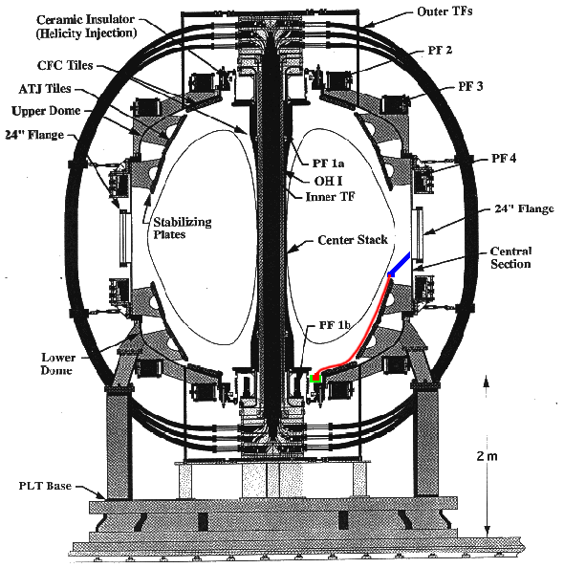
Baseline Parameters

Major radius ≤ 85 cm

Minor radius ≤ 68 cm

Plasma current 1 MA

Toroidal field 0.3-0.6 T

Heating and current drive 6-11 MW

Flat-top time 5-1.6 s

Flowing Liquid Wall on Center Stack and OB Divertor
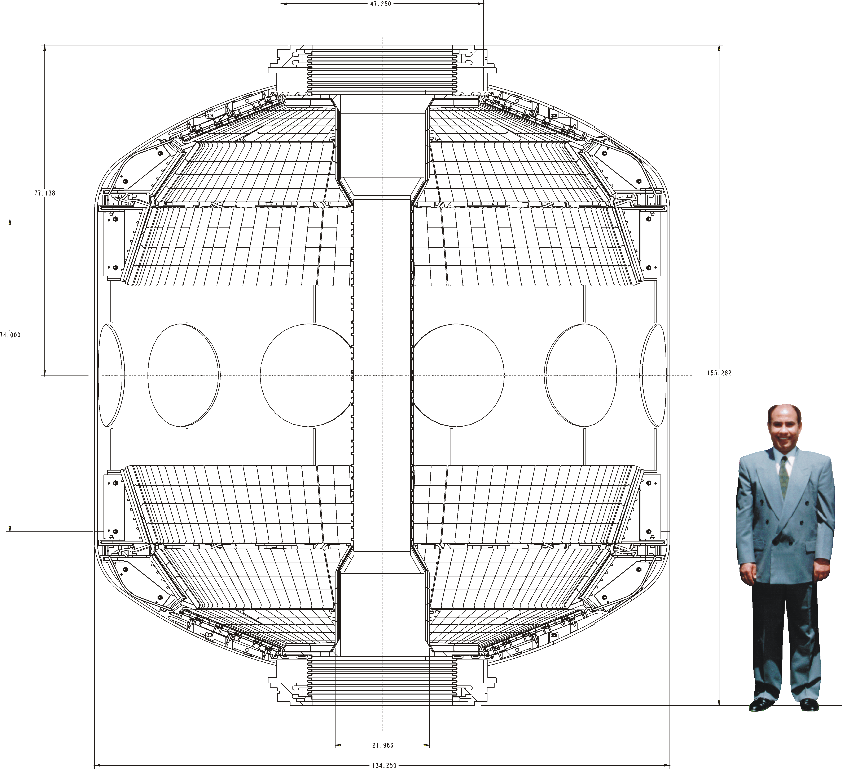
Flowing Liquid Walls in NSTX: Centerstack, Divertor and Passive plates
Capillary-Pore System Concept
Inlet manifold and exit “catch basin” are

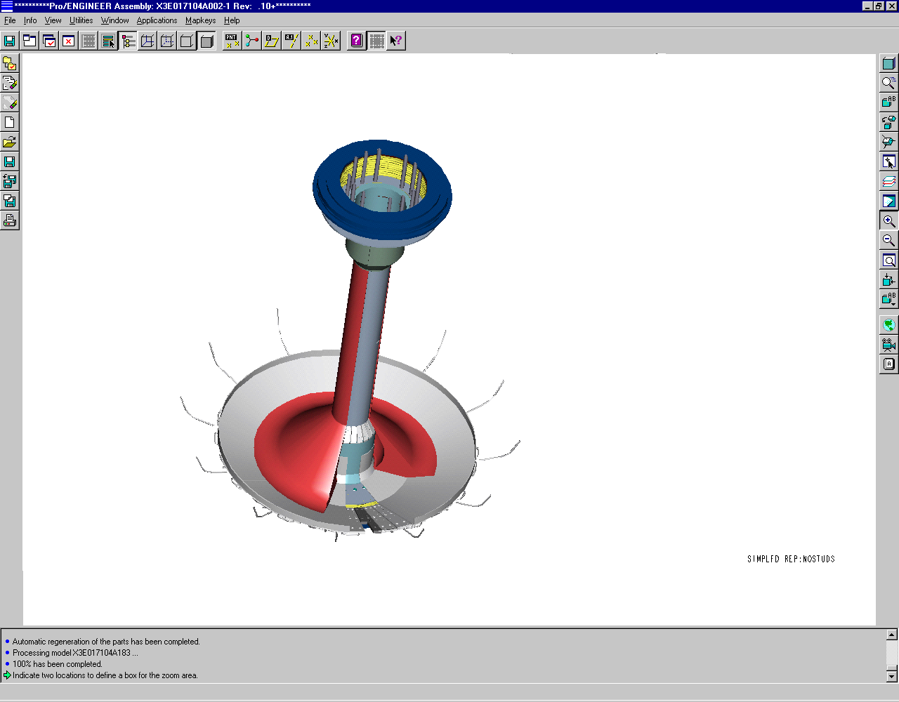
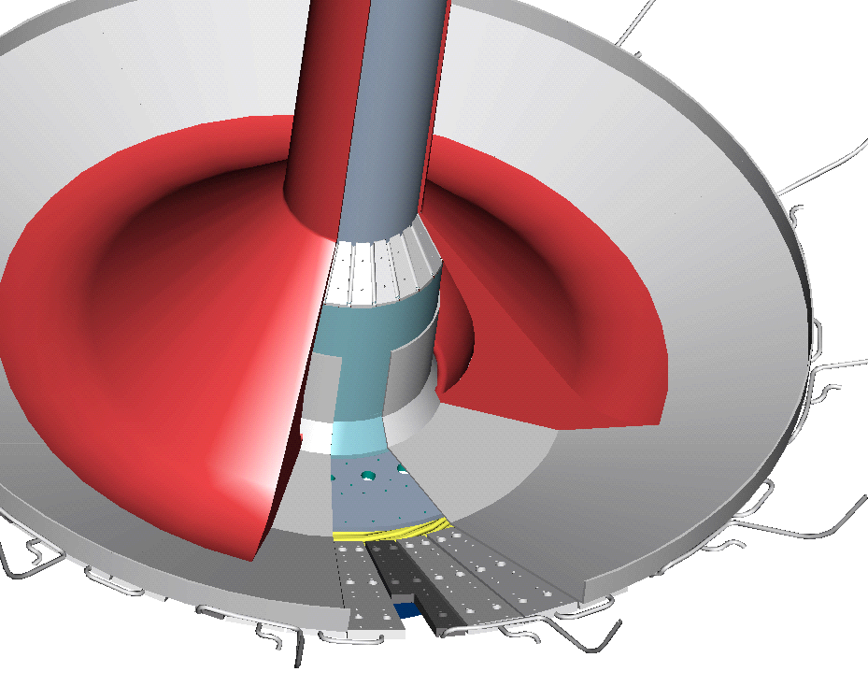
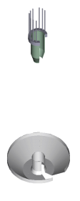
needed to put lithium on center stack
Flowing lithium
“Catch basin”
Inlet manifold
Catch basin

Exit piping must clear other ports and center stack
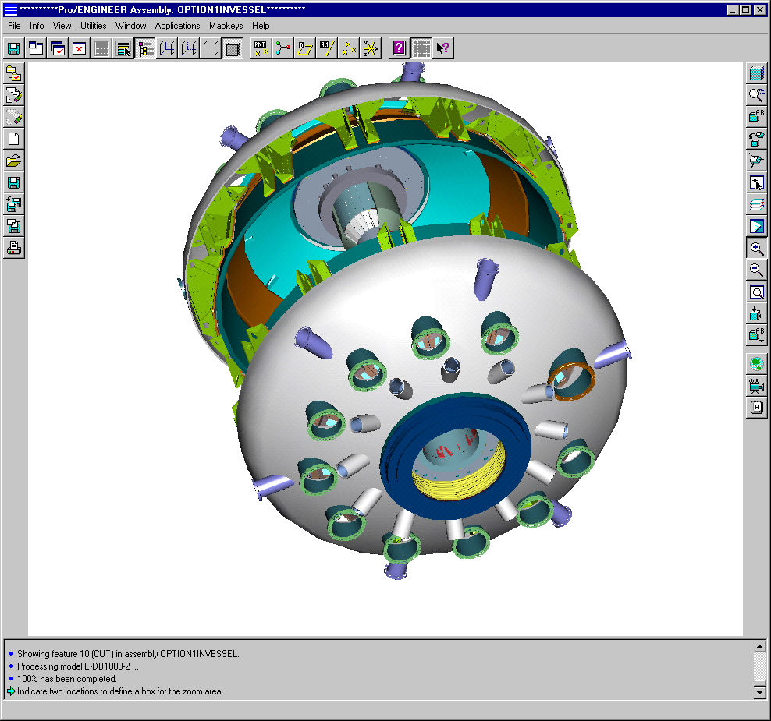
Exit piping

Exit piping must snake through divertor supports

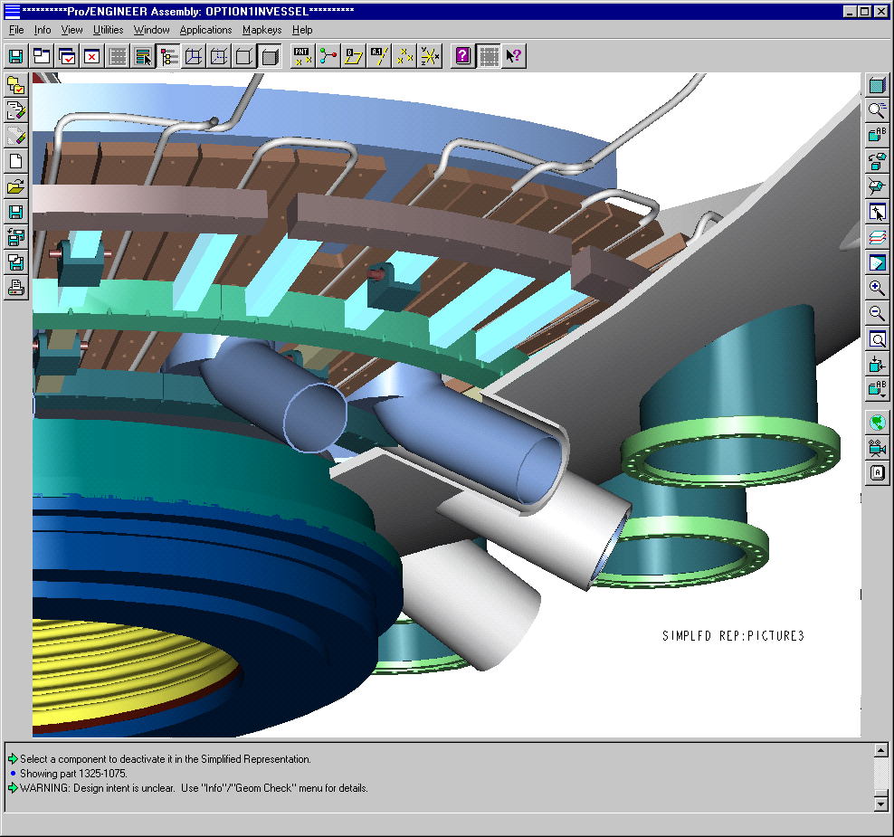
4 inch exit pipe,
typical 12 places

NSTX liquid wall experiment: A few configuration issues

- Concepts may only be compatible with single null configuration

- Helicity Injection Compatibility

Li shorts out insulators, unless insulators are protected (via catch basin)
Li is in contact with center stack, so piping must be insulated from vessel

- Limited space for exit flow piping

Divertor plates will probably require modification, but should clear support rings
Piping appears limited to about 4 inch I.D at 12 locations

- Smaller diameter (1.25 inch) inlet piping can be routed through instrument feed holes at top of center stack, but routing around the TF coil legs is still TBD

- Auxiliary heating penetration

Issues for Implementation of Flowing Liquid Walls in NSTX

Challenges
To develop and provide liquid wall technology systems that satisfy NSTX conditions before installation

- Time is limited (~ 5 years)
- It is prudent for APEX Task 1 to clearly define NSTX relevant flowing liquid wall goals and issues (Performance requirements)

Major Issues can be grouped into the following categories for effective execution:

- handling and safety including on-site ES&H
- technology maturity (e.g. flow pumps, clean-up systems etc.)
- (Magneto)hydrodynamics including nozzle designs and possibly penetrations
- heat transfer capability and transient phenomena
- materials and insulators, and
- diagnostics

3 and 4 require a significant, combined modeling and experimental research effort, yet, they can be addressed off-line without using plasma.

Developing a stable flowing liquid metal configuration across complicated magnetic fields (as in NSTX) is challenging
(data from Douglass S.Darrow for discharges with beta of 10%)
- Normal B components > 0.01 T ⇒ Flow damping expected (film thickness to grow)
- No centrifugal force available for stabilizing flow. Moreover the eddy current forces generated by the poloidal B components could pull lithium off the surface ⇒ may require using external electrical currents to restrain the liquids (Woolley’s concept)
- Gravitational force may not be adequate for pumping. Flowing lithium wall flow only during plasma shot, while liquid lithium drain and pumping only between shots.

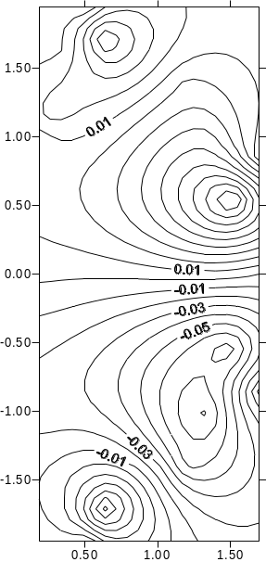
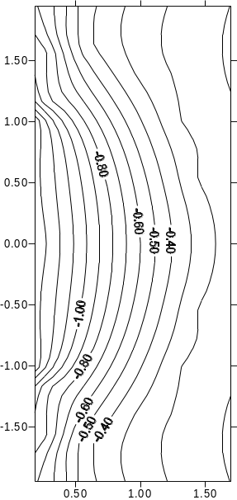
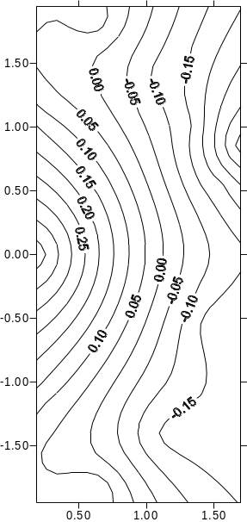
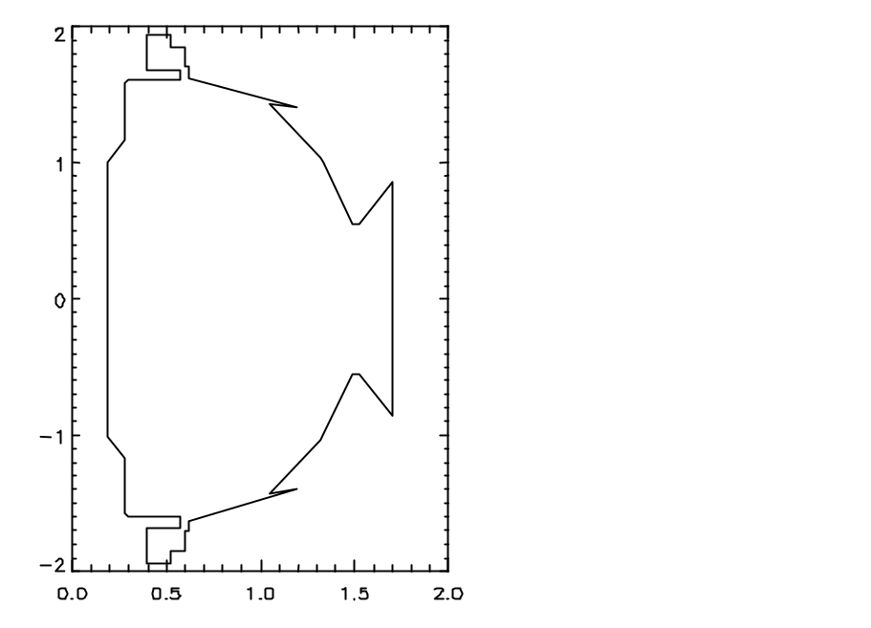
Normal radial field
Toroidal field
Poloidal field
Preliminary MHD Results

Effects of Radial Magnetic Field Variations on an Axisymmetric Lithium Annular Film Flowing along the NSTX Center Stack
(The effect of the poloidal field on the flow characteristics is not yet taken into account due to the present modeling capability)
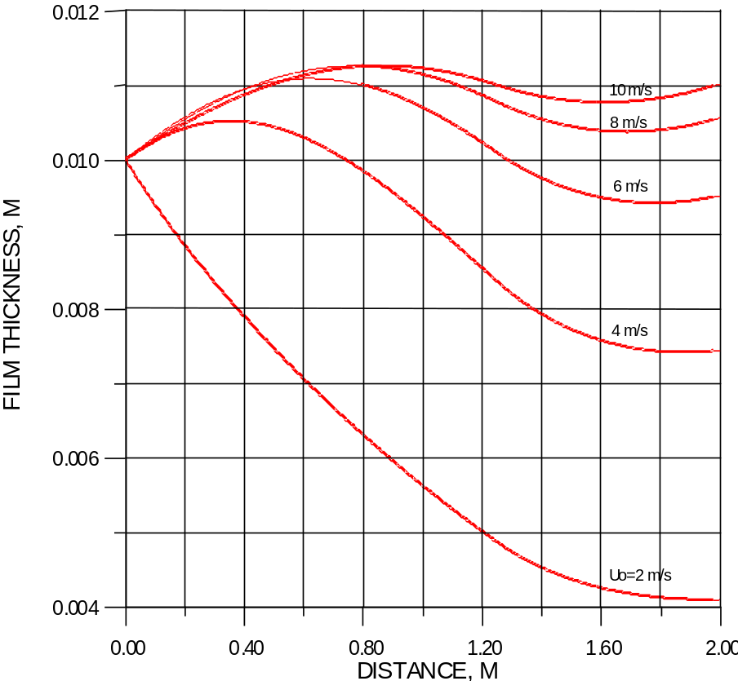
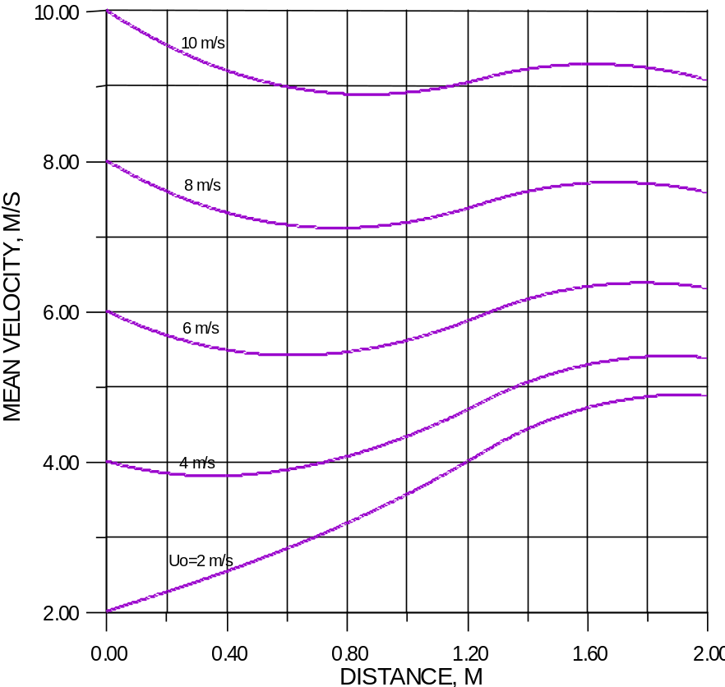
Film thickness varies as flowing lithium proceeds center stack downstream as a function of velocity
Corresponding velocity changes along the center stack
Heat Transfer Capability- During normal operation, lithium appears to have reasonable surface temperatures along NSTX center stack due to its high thermal conductivity (short flow path and manageable heat loads)
Lithium melting temperature = 180.6 C
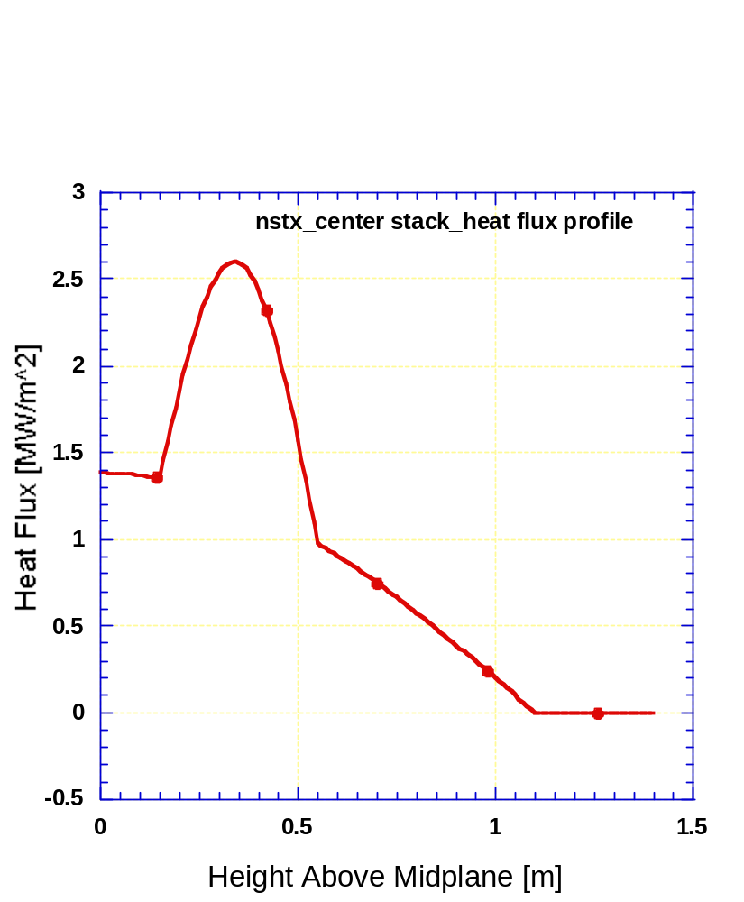
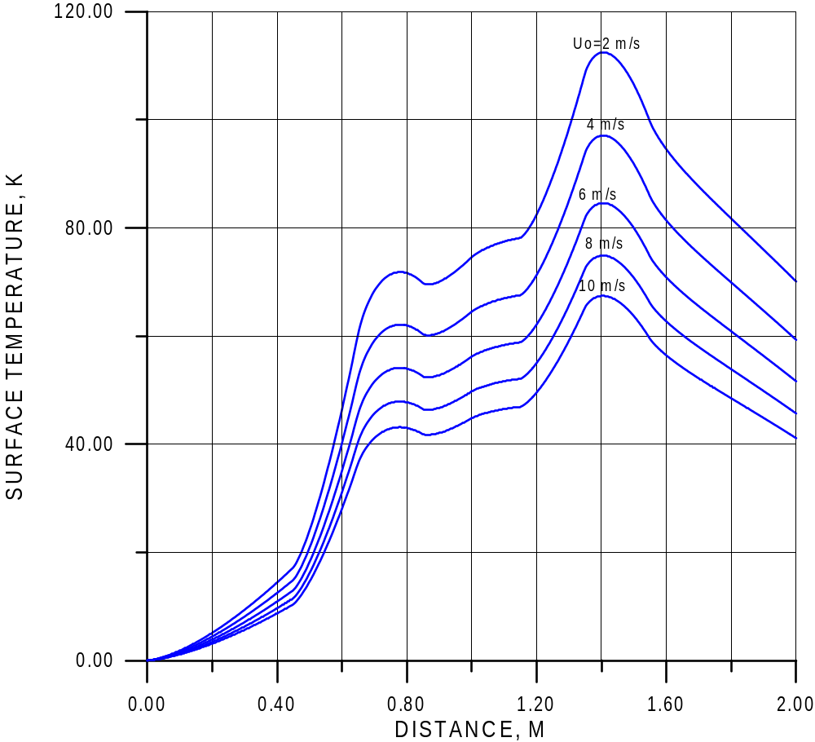
P_{heat}= 10 MW (RF and NBI heating)
Rajesh Maingi (1/13/00 version)

Lithium surface temperature increases as flow proceeds downstream as a function of lithium inlet velocity
- Predictable heat transfer (MHD-Laminarized Flow), but 2-D Turbulence may exist
- Laminarization reduces heat transfer
To limit the field penetration for wall stabilization requires the operation of the flowing lithium wall with a Magnetic Reynolds number (Re_{m}= σμ_{o}vh) greater than 1 [a much higher velocity than it is needed for heat transfer]

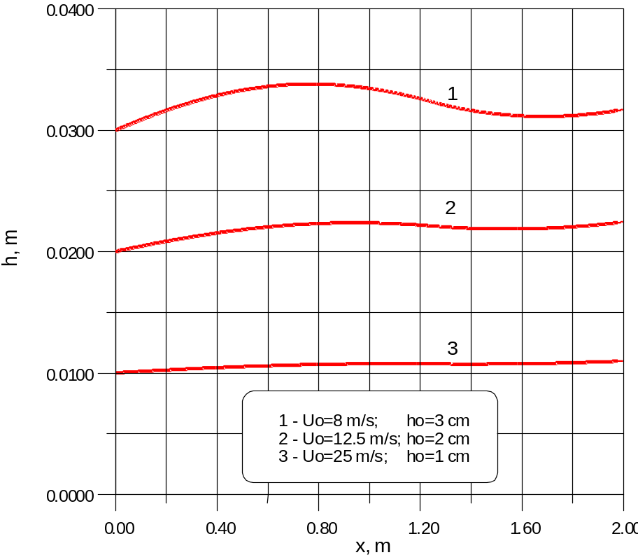
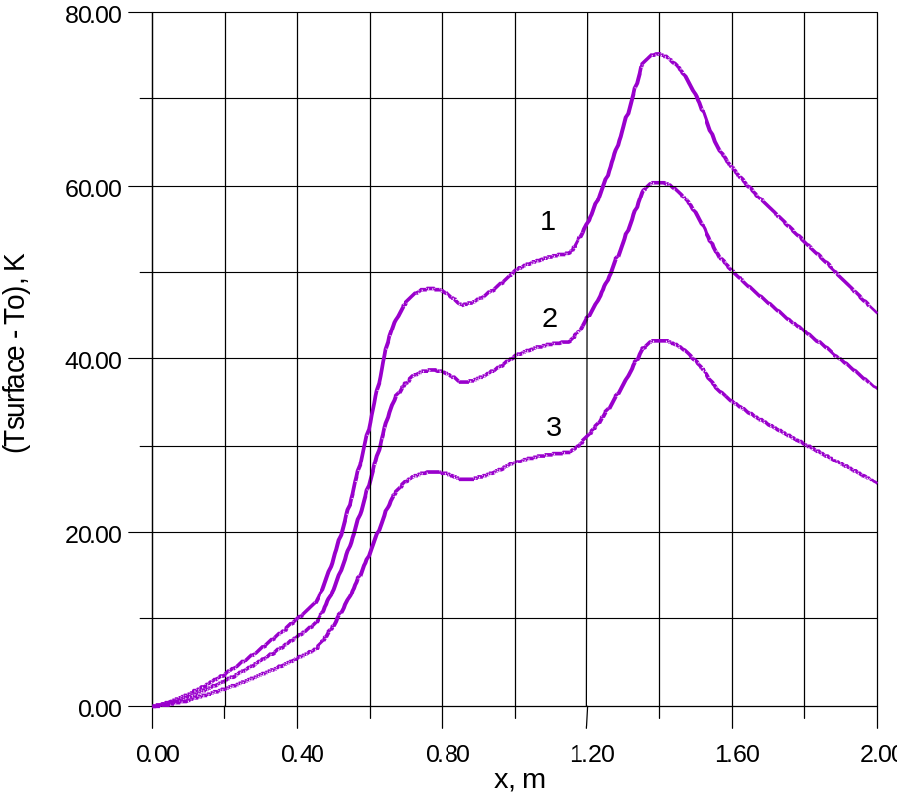
Lithium film height
Surface temperature increase

Note that:
- As developed, liquid metal magnetohydrodynamics mathematical formulation is valid with Re_{m} <<1
- As Re_{m} >1, the induced magnetic field is at about the same order of the applied magnetic field
What will be the maximum allowable flowing liquid wall temperatures in NSTX? (Preliminary Thoughts-Tom Rognlien)
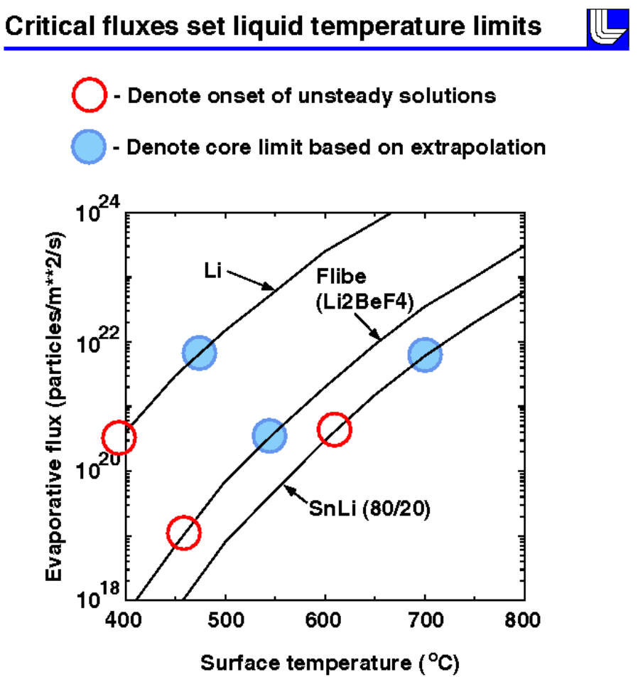
At fixed density, impurity intrusion, and thus allowable wall temperature, is determined by (at least) two main effects:

Radial power flux

Reactor-sized slab: radial power flux = 0.12 MW/m**2

NSTX (4 MW, area = 30 m**2): radial power flux = 0.12 MW/m**2

Consequently, for this aspect of the problem, the two cases are the same.

Axial lost time versus the radial diffusion time

NSTX would be better because of the shorter connection length and somewhat better flushing action.

Low-recycling edge density very dependent on edge fueling source
Need to evaluate sputtering and shielding for lower edge densities.
ITER-size calculations (edge density of 4e19 1/m³)

Near term goal is to develop an R&D plan and identify Facilities to address these Issues (DRAFT)

- CDX-U plasma physics issues, concept exploration including edge plasma modeling
- Off-line magnetohydrodynamics and heat transfer experiments and modeling as well as liquid wall technology development
- NSTX in-house preparation, ES&H
FY 2000
FY 2001
FY 2002
FY 2003
FY 2004
FY 2005
CDX-U
UCSD PISCES
Planned CDX-U Concept Exploration – Physics Technology
NSTX Projected Operating Conditions Facility Preparation, In –house ES& H Preparation
Liquid metal free surface flow magneto-hydrodynamics in a torous facility including engineering elements (various nozzles)
Heat transfer capability experimental study
MHD, heat transfer and edge plasma modeling and analysis to help identify issues and define experimental parameters
Accident scenario analysis, mitigation schemes and safety evaluation
NSTX flowing liquid wall engineering design, construction and shake down tests
NSTX flowing liquid wall installation
MHD/Heat transfer integrated tests

Application of K-epsilon model to Heat Transfer at Free Surface Flow in a Magnetic field

Interactions of Turbulent Eddies with a Free Surface

Two effects:

- The length scale of the turbulence is reduced by the free surface due to geometrical restrictions and consequently the dissipation rate is increased.

ε ∝ k ^{3/2}/l

However, the length scale (l) at a free surface is finite, whereas the length scale goes to zero at a solid wall.

- The free surface causes a redistribution of the velocity fluctuations, damping the vertical fluctuations and (owing to continuity) enhancing the horizontal ones.

Additional effects due from the existence of a magnetic field

- Joule dissipation (applied in the bulk and at the boundaries)

Mathematical Formulation

Momentum equation:

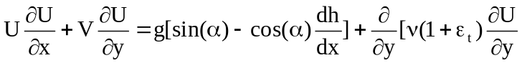]

Continuity equation:

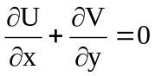

Free surface kinematic condition:

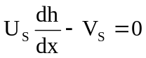

Energy equation:

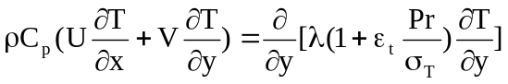

Turbulence kinetic energy equation:

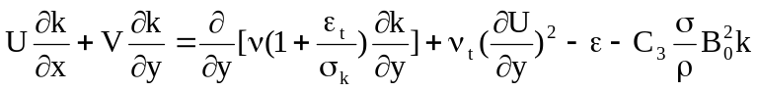

Dissipation rate of the turbulence kinetic energy equation:

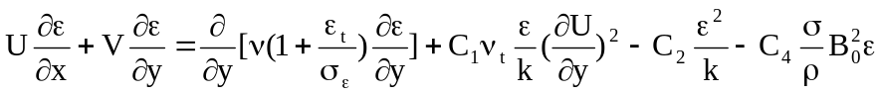

Eddy viscosity:
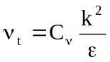
Boundary conditions at the Backing Wall (Modified wall function method)

Boundary conditions at Free Surface

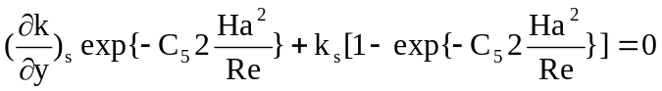; 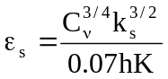 .
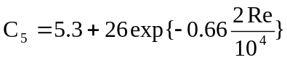

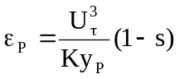; 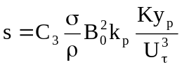 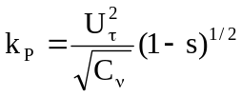
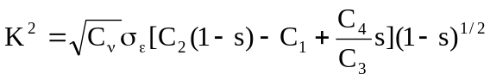

Choice of Closure Constants

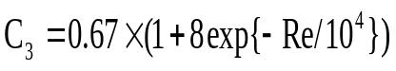
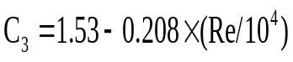
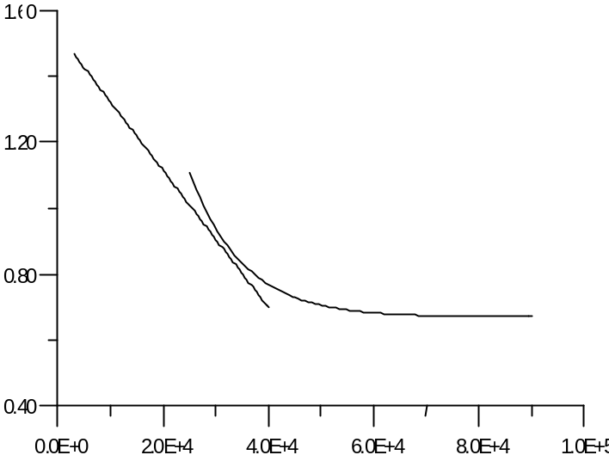
C₃
Re
C₁ C₂ C_{ν}σ_{k} σ_{ε}

Present UCLA model (wall-functions method)
1.441.920.091.0 1.3

A. Inoue, M. Takahashi (Low-Reynolds Number Model) [J. of Experimental Thermal and Fluid Science 1994; 8:46-57]

1.552.0 0.091.0 1.3

C₃C_{4σt}

Fig. 11.0ε_{M}/ε_{H}

2/31.0 1.0 for air
f(Re,Pr) for Hg

(ε_{H} obtained from Ueda’s experimental data- Int. J. Heat Mass Transfer, Vol. 20, pp. 1127-1136, 1977)

Fig. 1

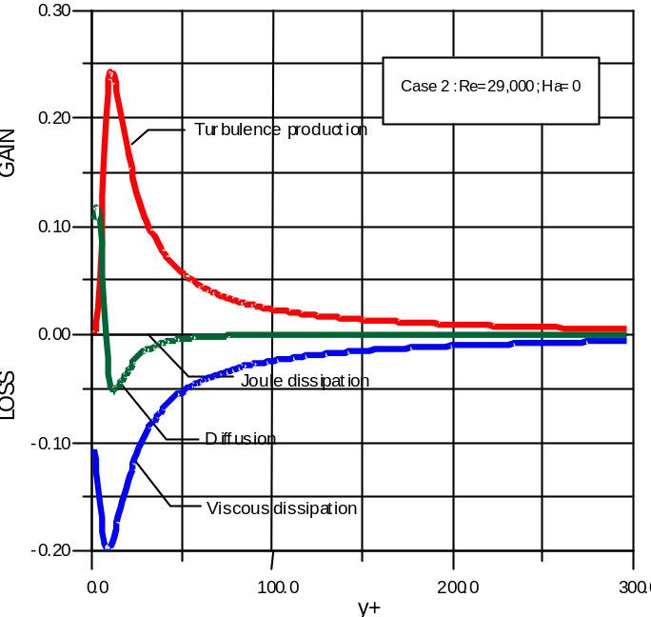
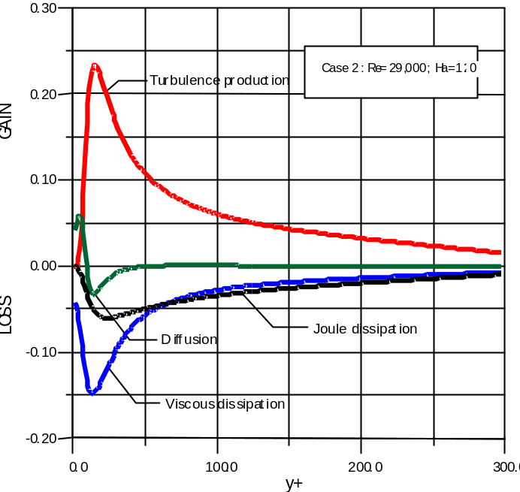
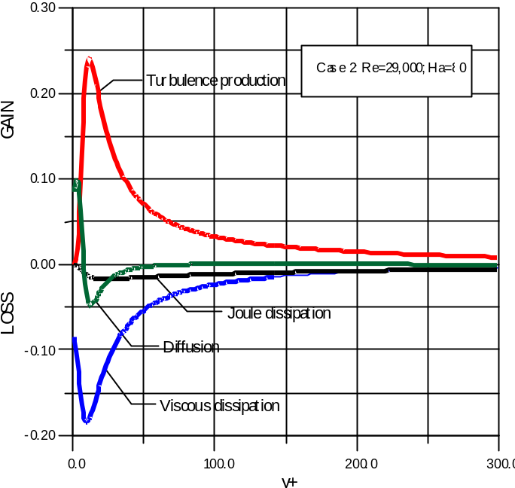
Turbulent Kinetic Energy Budget

Example Calculations for a Closed Channel with a Magnetic Field Applied in the Toroidal Direction

Joule dissipation increases as Ha number increases, while the turbulent production is approximately the same
Ha= 120
Ha=0
Ha=80

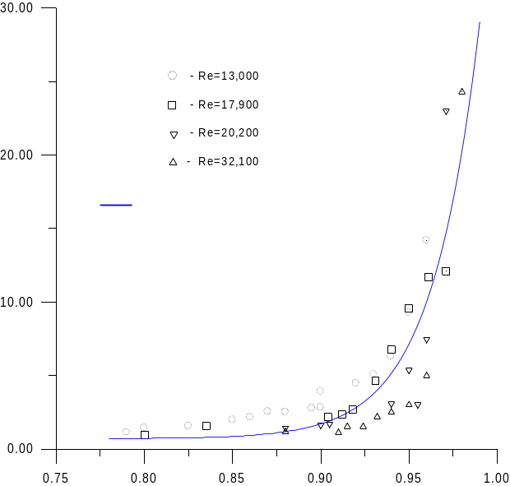
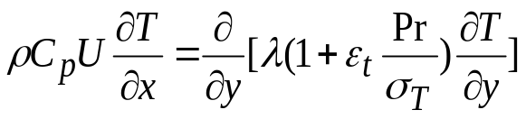
Flibe Free Surface Temperature Magnitudes Highly Depend on the Turbulent Convection near the Free Surface

Heat transfer degradation at Flibe free surface results from:
the damping of the normal velocity component at the free surface (σ_{T}) and
suppression of turbulence by the field (ε_{T}).
Ordinary Κ−ε model was extended to account for:

Free surface boundary
MHD Joule dissipation

UCLA New Model
y/h
Turbulent Prandtl number growth near the free surface
σ_{T}
Energy Eq.
ΔT, K
α, degree
1 - B₀=10 T; σ_{T} UCLA model
2 - B₀=0; σ_{T} UCLA model
3 - B₀=10 T; σ_{T}=0.7
4 - B₀= 0; σ_{T}=0.7
(3 & 4 no free surface effect)

0
.
0
2
0
.
0
4
0
.
0
6
0
.
0
8
0
.
0
1
0
0
.
0
0
1
0
0
2
0
0
3
0
0
1
2
3
,

4
Free surface temperature rise at 8 m downstream with surface heat flux of 2 MW/m² for an equivalent Flibe free surface flow of 10 m/s
Pipe flow/no free surface effect
Free surface flow
Thin wall concept
Thick wall concept
Summary

1. The physics and engineering benefits of flowing liquid walls appear to be tremendous. They provide incentives for exploring liquid walls.

- NSTX provides excellent opportunities for conducting a proof-of-principle experiment of flowing liquid wall.

- APEX Task I is identifying various flowing liquid wall options in NSTX.

- Preliminary results of magnetohydrodynamics and heat transfer analysis have identified possible operating conditions for axisymmetric annular flowing lithium film for the NSTX center stack.

Further analysis will be performed for:
- toroidally disconnected flow on the center stack
- flow in divertor region with prototypical toroidal field gradient and vertical field
- exit design

- Plasma edge analysis with a lower recycling edge density using the actual magnetic geometry of NSTX will provide guidance on the maximum allowable free surface temperatures.

Summary (cont’d)

- The Challenging Scientific Issues of Liquid Walls require the collective ingenuity and creative minds of scientists in several technical disciplines.

Potential issues concerning the implementation of the flowing liquid wall tests are being considered.

An R&D plan will be developed to serve as a guiding-tool.

CDX-U results combined with magneto-hydrodynamics and heat transfer data obtained from various facilities provide design database for NSTX flowing liquid walls.

- Integration with the NSTX Team plays an important role in realizing the success

A working group to facilitate the implementation of flowing liquid wall tests in NSTX has been proposed.

- An ordinary K-epsilon model has been successfully modified to take into account MHD and free surface boundary conditions

MHD suppression negligible for thin layer flows (< 10 cm), but significant for thicker layer flows

