Thick Liquid Walls Will

Enable High Power Density ICC Concepts

And

Offer an Exciting Opportunity for:

- An Attractive and Competitive Fusion Power

- Affordable, fast R&D path

Mohamed Abdou
Presentation to FPA Meeting, Marina Del Rey, 1/26/99

Results on Liquid Walls from APEX are Exciting

- Thick Liquid walls ( > 30 cm) Can be Formed and Maintained as Swirling Flow in ST, FRC, and Other ICC Configurations

- Innovative Solutions for Plasma-Liquid Compatibility

- High Power Density, High Performance Capability
- Neutron Wall Load up to 30 MW/m²
- High Efficiency ( > 45%)

- Moving the structure behind the liquid provides Major advantages
- Substantially Lower Activation, Longer Life
- Major Enhancement of Reliability and Maintainability

- There is Highly Beneficial Synergism between MFE and IFE

6) R&D Path: Much Lower Cost, Shorter Time

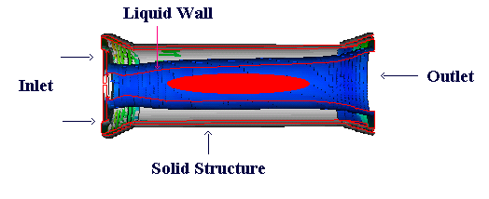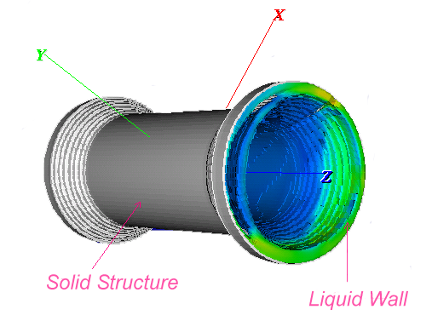Swirling Thick Liquid Walls for High Power Density FRC
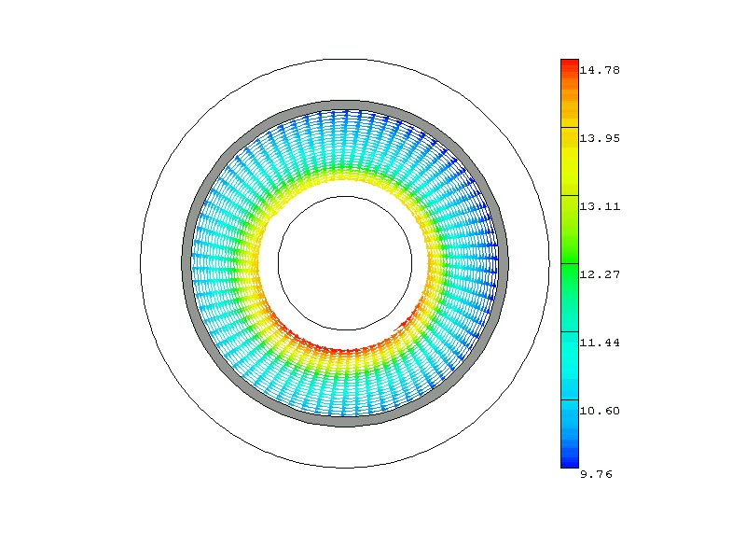
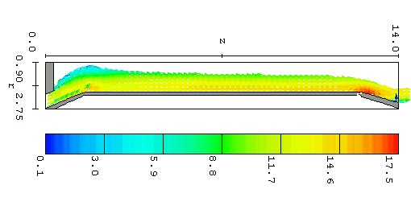
- Design: Horizontally-oriented structural cylinder with a liquid vortex flow covering the inside surface. Thick liquid blanket interposed between plasma and all structure
Calculated velocity and surface depth

- Computer Simulation: 3-D time-dependent Navier-Stokes Equations solved with RNG turbulence model and Volume of Fluid algorithm for free surface tracking

- Results: Adhesion and liquid thickness uniformity (> 50 cm) met with a flow of V_{axial} = 10 m/s, V_{θ,ave} = 11 m/s

Toroidally Rotating Thick Liquid Wall for the ST
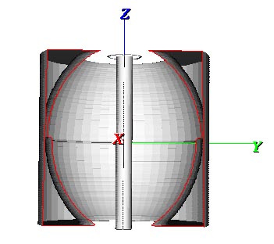
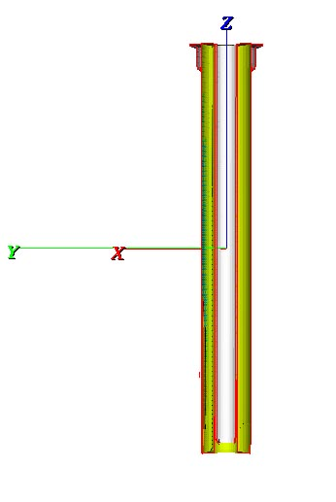
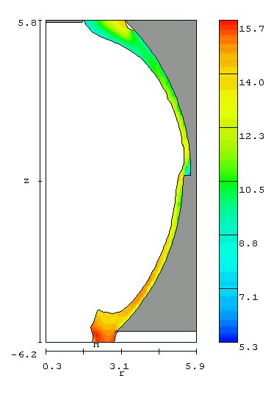
Design Concept:

Thick liquid flow from reactor top

Outboard: Fluid remains attached to outer wall due to centrifugal acceleration from the toroidal liquid velocity

Inboard: Fast annular liquid jet
Simulation Results:

Step in outboard vacuum vessel topology helps maintain liquid thickness > 30 cm

Calculated outboard inlet velocity,
V_{poloidal} = 4.5 m/s, V_{toroidal,ave} = 12 m/s

Inboard jet V_{z} = 15 m/s is high to prevent excessive thinning, < 30%

Motivation for Research on Liquid Walls, High Power Density

Derive from the Objectives and Priorities of the Fusion Community

- One of the six five-year objectives from the Leesburg Community Workshop (December 96):

“Accomplish marked progress in the scientific understanding of technologies and materials required to withstand high plasma heat flux and neutron wall load”

- A letter directed to Dr. Anne Davies in January 1998 by 23 distinguished members of the fusion community articulated well the need for research on High Power Density and provided momentum and focus to research on Liquid Walls. Poignant excerpts:

“Most of the alternate concepts, innovative concepts and advanced tokamaks are high beta devices which should allow them to be built in smaller unit sizes than conventional fusion machines. … There is one major difficulty present in all of the toroidal confinement devices… “they’require high wall loads if they are going to have comparable mass power densities and thus be able to compete with conventional power sources.”

“…it is timely for the technology side of OFES to consider a new focus to develop first wall/blanket schemes which can demonstrate high heat and neutron fluxes.”

“This technology challenge is every bit as much of a world class problem as producing a thermonuclear plasma.”

“It is also very much in keeping with the new emphasis on science and innovation in the program.”

“…it would directly address the problem that our critics outside of fusion view as being fusion’s Achilles’ Heel.”
Anne Davies letter

Liquid Walls Can Substantially Reduce Time and Cost of Major Facilities Prior to DEMO

Proof of Principle and Proof of Performance Can be obtained with a combination of Computer Simulation and Laboratory Experiments
 | Major Facilities for:
 | Solid Wall/Evolutionary | Liquid Wall/Revolutionary
Key Testing Environment | -NEUTRONS  -Surface heat flux | - Surface heat flux
Dominant Testing Effects | -Radiation Damage  -Failure Modes/Rates  -Maintenance Time | -Hydrodynamics/heat transfer
Capital Cost for a Major Facility | - Component Testing (Facility) > $2B  - IFMIF-type > $1B | Thermofluid facility  ~ $50 M
Time to obtain test data | > 20 years | 5 years
Operating Cost | > $2 B | $50 M
Total Cost | $5 Billion | $100 Million
- Synergism between IFE and MFE will also SAVE MONEY
- Proof of Principle and Proof of Performance for Chamber Technology LIQUID WALL Concepts can be realized at a modest cost and in less than a decade (in sharp contrast to the case for solid walls/Evol. Concepts)

