From: Clement Wong Note #1
To: DCLL Design team Date: September 9th, 2005
Subject: DCLL TBM Reference Design Parameters and Summary

Content

1. Introduction
2. DCLL design parameters
2.1 Geometry
2.2 Heat loads
3. DCLL TBM conceptual design
4. Reference design operating temperatures
5. Ancillary circuits and equipment

Appendix

A1. ITER operation schedule
A2. DCLL test plan
A3. Detailed heat loads for the ITER DT phase

-------------------------------------------------
- Introduction

This is a memo specifying the basic geometric and thermal input parameters for the US ITER DCLL Reference TBM design. These parameters are to be used to define the corresponding ancillary equipment near the test port, on the transporter and in the torus cooling water system (TCWS) vault as shown in section 5. This set of parameters should also be used for the on-going planning and costing exercise for our Reference DCLL design, which has the following scope: design, fabricate and commission the first DCLL TBM to be tested in ITER on day-one, to support the DCLL testing goals during the HH phase of ITER and to prepare the module design and ancillary equipment for subsequent modules and corresponding tests.
The US DCLL TBM mission statement and test plan are given in reference 1. The ITER operation and corresponding DCLL test plan for the first 10 years of ITER operation are also summarized in Appendix A1 and A2. Four sequential test articles are envisioned. They are the Electromagnetic/Structural TBM for the hydrogen (HH) phase, Nuclear Field/Tritium Production TBM for the DD and low duty cycle DT phase, Thermofluid/MHD TBM for the low duty cycle DT phase and Integrated TBM for the high duty cycle DT phase of ITER operation.
The Reference DCLL TBM design configuration is designed to handle the DT phase of the integrated module design as our point design; the coolant flow rates for helium and Pb-17Li can then be adjusted to operate in the HH phase of ITER operation. Minor design changes can be envisioned in order to satisfy the HH phase testing goals. Our immediate costing effort is focusing on this HH phase test article. Accordingly, we will design the corresponding ancillary equipment that will satisfy the first 10 years operation of ITER. We will have to decide on the schedule of installing the ancillary equipment and then provide corresponding inputs to the on-going costing exercise.
Detailed design parameters will be iterated and up-dated with time when relevant results from R&D and analyses are available. Please send your notes, comments and technical results on the DCLL design to Clement Wong for project documentation and distribution.
In the following, section 2 presents the design parameters of our Reference design, including the latest geometry specified by the test blanket working group (TBWG) at the last TBWG-15 meeting in July, 2005. Section 3 describes the conceptual DCLL design we have been working and on and similar configuration will be used for our Reference design. Section 4 presents the material temperature parameters that we will use and section 5 describes the ancillary circuits, equipment and parameters.

- DCLL Design parameters
2.1 Geometry

The “half-port” TBM itself is supported in a frame (see Fig. 1 and 2) that occupies an equatorial ITER port with an opening of 2.16 m height and 1.708 m width. As shown, the test port is located at about the outboard mid-plane of ITER. A transporter is located behind the TBM and shield for the holding of some of the dedicated ancillary equipment for the specific test module. The set of parameters given in Table 1 is based on the total test port frame thickness of 23 cm, which includes a 3 cm step of the frame (so called “dog-leg”) and a 20 cm thick at the front of the frame box as shown in Fig. 1. Accordingly, with a gap of 2 cm between the DCLL module and the frame, our DCLL module will have a height of 1.66 m and a width of 0.484 m. The corresponding radial depth is 0.413 m. This depth was selected from the minimization of the PbLi volume of <0.27 m³, and the necessary radial depth of the helium distribution plenum. Materials selected for the Reference DCLL TBM are given in Table 2.
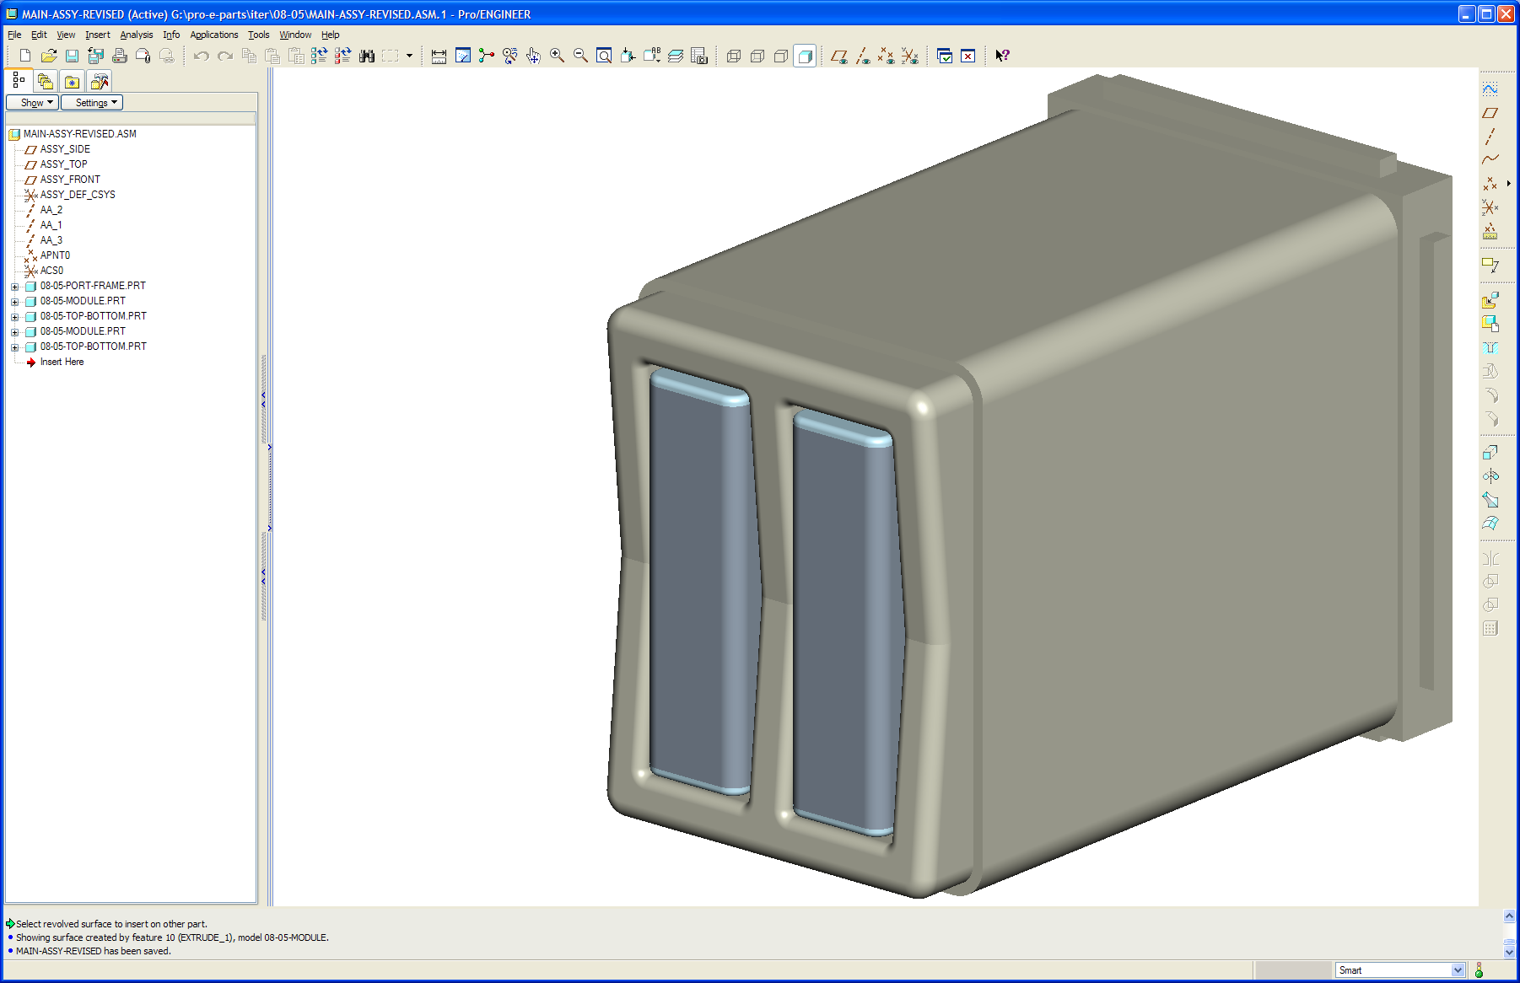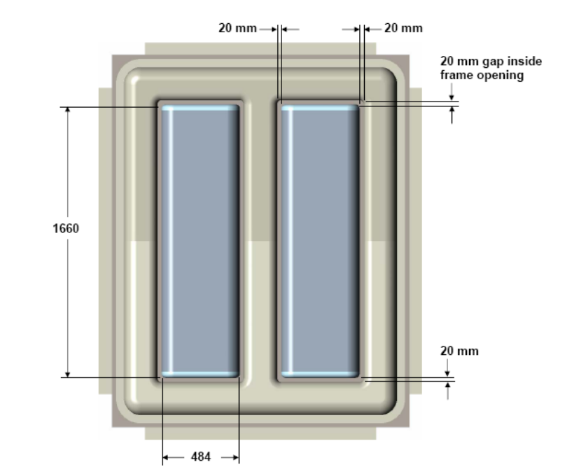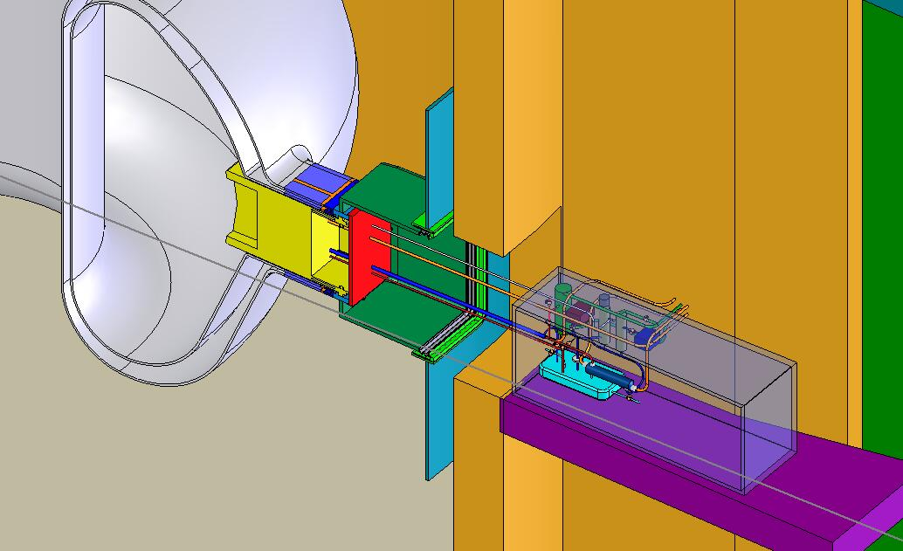
3-D TBM frame and vertical modules

Transporter
All frame frontal thickness
is 20 cm thick
ITER

Fig. 1 ITER, test port and TBM frame showing two vertical half modules separated
by a support post of 20 cm thick.

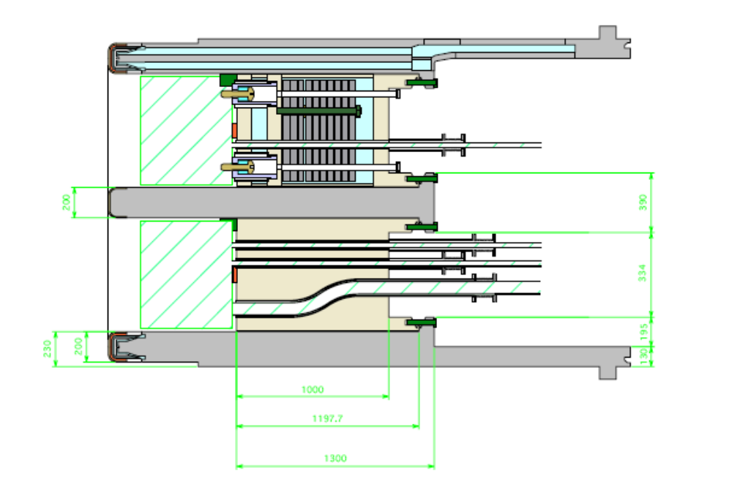
Fig.2. ITER test port Frame Design
(You may have to enlarge the figure to read the dimensions in light green color.)

Table 1 DCLL TBM geometry

Module Geometry:
Port frame front thickness, mm | 200
“Dog leg” width, mm | 30
Frame and TBM gap width, mm | 20
TBM height, m | 1.66
TBM width, m | 0.484
Radial depth, m | 0.413
Frontal area, m² | 0.803
First wall shape | flat

Table 2 DCLL TBM design materials

 | DCLL Design
Module Materials:
Structural material | Ferritic Steel (FS), e.g. F82H
Breeding material | Pb-17Li
FW/structural coolant | 8 MPa helium
Intermediate loop coolant | 8 MPa helium
Flow channel insert | SiC_{f} /SiC or metallic sandwich e.g. FS/Al₂O₃
FW coating | 2 mm Be

2.2. Heat Loads

Detailed heat load conditions during the ITER D-T phase for the TBM are given in the Appendix A3, as provided by ITER. To simplify our design assessment, Table 3 presents the selected D-T phase ITER parameters, and corresponding point design thermal parameters.

Parameters shown in Table 3 represent the point design case for the integrated module design based on the power removed by the Pb-17Li and He streams. In the design of ancillary equipment as presented in section 5, the equipment will be over designed with coolant mass flow rate to provide flexibility of operating the TBM components to lower than the maximum allowable temperatures. The relationship between the three coolant loops are presented in sections 3 and 4.

Table 3. ITER D-T phase and DCLL point design parameters.

ITER Neutron and surface loading:
Neutron wall loading for 400s, MW/m² | 0.78
Average surface heat flux for 400s, MW/m² | 0.3
Max. surface loading during transient for 10 s, MW/m² | 0.5
Blanket energy multiplication | 1.006
Tritium production rate during pulse, gm/s | 1.027 x 10⁻⁶
Tritium breeding ratio, Li-6 enrichment @ 90% | 0.741

Thermal hydraulic parameters:
Module thermal power for 400s, MW | 0.871
FW/structure primary He loop:
Module power fraction | 0.54
He thermal power for 400s, MW | 0.472
He Tin/Tout, C/C | 300/440
He system pressure, MPa | 8
He mass flow rate, kg/s | 0.649
He volume flow rate, m³/s | 0.11
Pb-17Li loop:
Module power fraction | 0.46
PbLi thermal power, MW | 0.4
PbLi pressure, MPa | 2
TBM PbLi Tin/Tout, C/C | 300/470
PbLi mass flow rate, kg/s | 12.44
PbLi volume flow rate, m³/s | 1.33x10⁻³
Intermediate helium loop:
thermal power, MW | 0.4
pressure, MPa | 8
Tin/Tout, C/C | 180/300
He mass flow rate, kg/s | 0.64
PbLi volume flow rate, m³/s | 0.107

ITER H-H phase operation parameters, specified by ITER, are given in Table 4. We will be assessing the performance of the Reference DCLL design by tailoring the helium coolant flow rate of the primary coolant loop, since we will only need to handle the surface heating from the plasma. No neutron wall loading will be expected, this allows the consideration of a surrogate material, possibly stagnant electrically conducting liquid, other than circulating Pb-17Li for the assessment of structural loading and disruption effects. If Pb-17Li is used, it will not need to be enriched in Li-6. The FCI will be tested and the plan is to test prototypic SiC/SiC FCI but if necessary we will consider metallic insert like ferritic steel / alumina metallic sandwich design as an alternate.

Table 4 Heat Load Conditions During H-H Phase for Test Blanket Modules
(This is copied from reference 2 and no editing has been made.)

Parameter | Design values for test blanket module | Comments | Basis
Inductive operation . Fusion power 0 MW. Flat-top time 100-200 sec .
Heat flux during burn time in normal plasma operation | 0.11 MW/m²  up to 600 cycles  per year  (Total 1000 cycles  for 2.5 years) |  | Total Radiation Loss: 73 MW x 1.05 x 0.75 = 57.5 MW Peak heat flux: 57.5 MW / (680 m² x 1.06) x 1.41 (peaking factor: TBD) = 0.11 MW/m²
Surface heat flux due to MARFE or other phenomena | 0.3 MW/m^{2 (*)}  Steady-state (in a localized region^{(*)})  100 cycles  per year | MARFE (Duration; 10 sec) in the outboard region has a small probability.  When MARFE is detected, the plasma will be shut-down.  The heat load due to other phenomena can be steady-state, but the high heat load is localized.. | ^{(*)} In the case of steady -state condition, the average heat load in TBM is not more than 0.15 MW/m² (the average can be for the TBM overall, or in the toroidal or poloidal direction ).
Disruption heat load | TBM is recessed: 0.42 MJ/m²  Duration ms  180 cycles per year |  | 270MJ x 0.8^{(*)} / (680 m2 x 1.06) x 1.4 (peaking factor) =0.42 MJ/m²  ^{(*)}: ~80 % of the thermal energy can go to the FW at maximum. (Experimental data in JET and ASDEX-U)
Disruption heat load during current quench | 0.72MJ/m²  Duration 40 ms  180 cycles per year | All of the internal magnetic energy is assumed to be radiated with peaking factor 1.4. | 370MJ/ (680 m2 x 1.06) x 1.4 (peaking factor) =0.72 MJ/m²
Heat load due to ELM and "blob" | Negligible | The heat load due to ELM and "blob" will be negligible, considering the distance from the separatrix and recess of the TBM FW locations. | The heat load conditions due to these effects might be revisited based on additional experimental data in the future.
Neutron wall load on TBM FW | 0 MW/m²
Pulse length | Typical case;  100-200 sec (flat-top time)  1800 sec (repetition time)
Duty factor | Peak duty factor: Less than 0.25

3. DCLL TBM Conceptual Design Configuration

The following is a review of the DCLL conceptual design. The general configuration will be utilized for our Reference design. Fig. 1 shows the DCLL vertical half port module with respect to the ITER test port frame and test port.
A drawing of the DCLL sub-assemblies is shown in Fig. 3 (note that the module is shown with a curved FW, this is an old design drawing – the FW is flat in the Reference design). The sub-assemblies will form the box structure of the TBM. The support keys as shown in Fig. 3 will be inserted into matching slots in the shielding block located behind the TBM, and the four positioning pins will be inserted into the shielding block and used to set the TBM into the proper position and provide the radial support needed at the top and bottom during operation. Details of these supports will be worked on during the preliminary design phase of the DCLL project. The TBM was designed to accommodate the two fluid flows internally and maintain the total separation between them as shown in Fig. 3 and 4. Also it is designed to withstand the maximum He pressure in case of an internal leak from the He into the Pb-Li chambers. Disruption loading impacts will have to be evaluated in detail.
Helium is used to cool the first wall and all FS structure, and the self-cooled breeder Pb-17 is circulated slowly in the poloidal direction as shown in Fig. 4. Fig. 5 shows the relative location of the test module in the test port, transporter location. Fig. 5 also shows a module cross-section sketch. A plan view of the module is shown in Fig. 6. A possible scheme for the installation of the FCIs shown in Fig. 7. The FCI in the bends as pictured here maybe unnecessarily complex and those in the manifold regions are not pictured. A redesign of these FCI shapes is expected when details of the manifold regions have been settled.

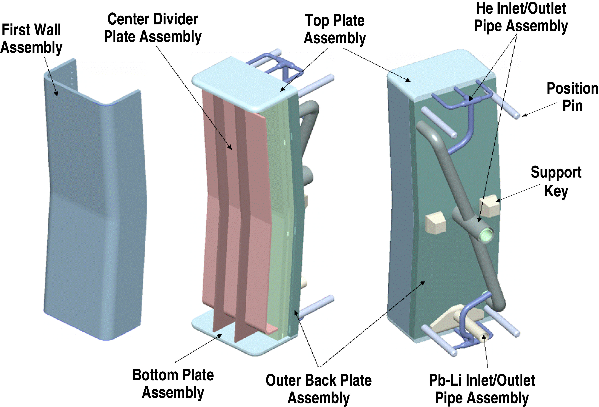
Fig. 3. DCLL TBM sub-assemblies.
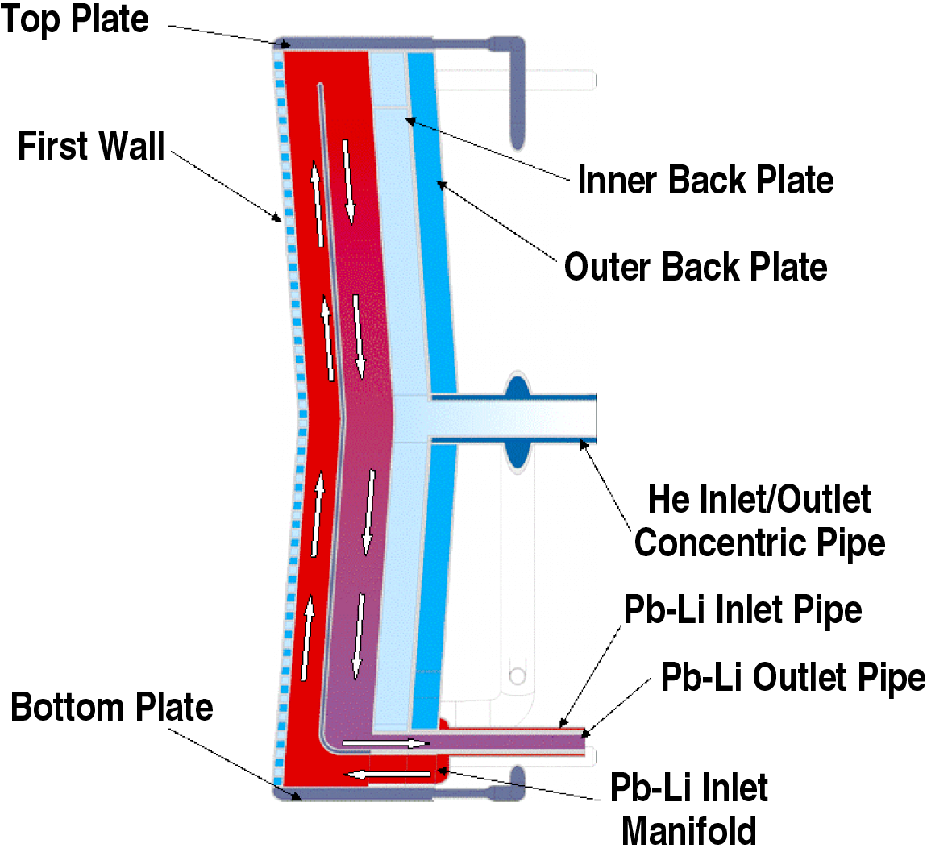
Fig. 4. 2-D schematic of the Pb-17Li circuit in the TBM.

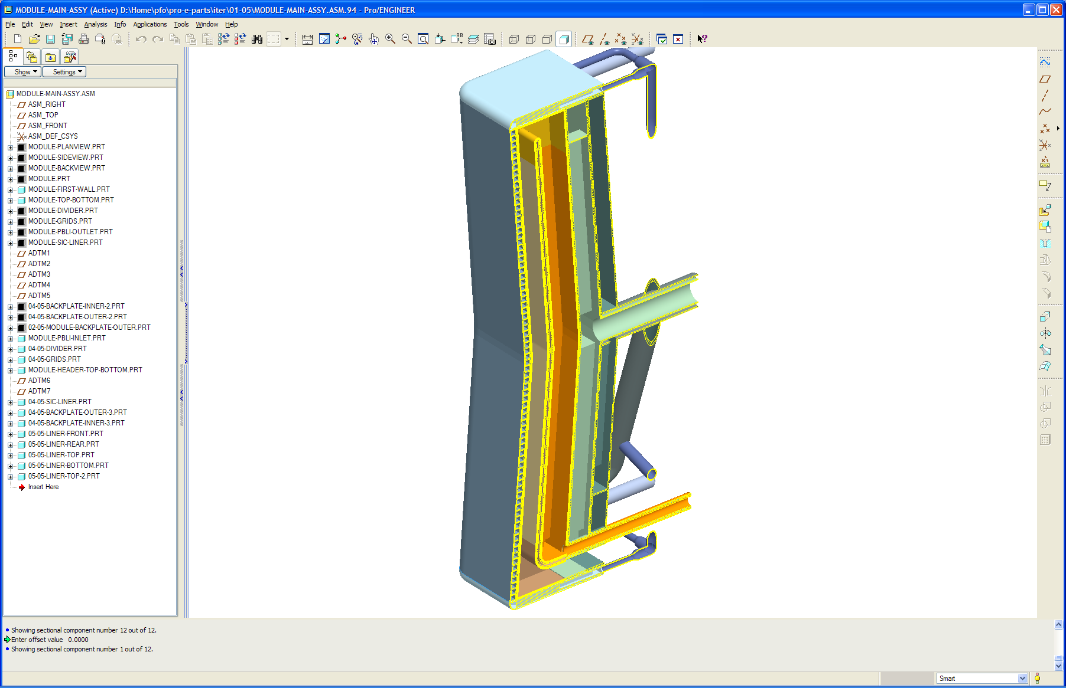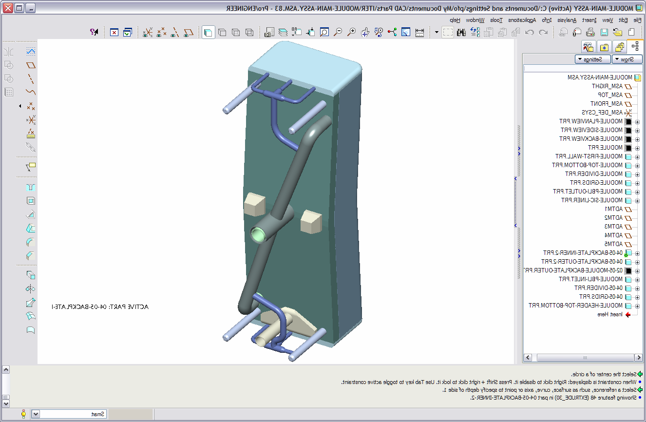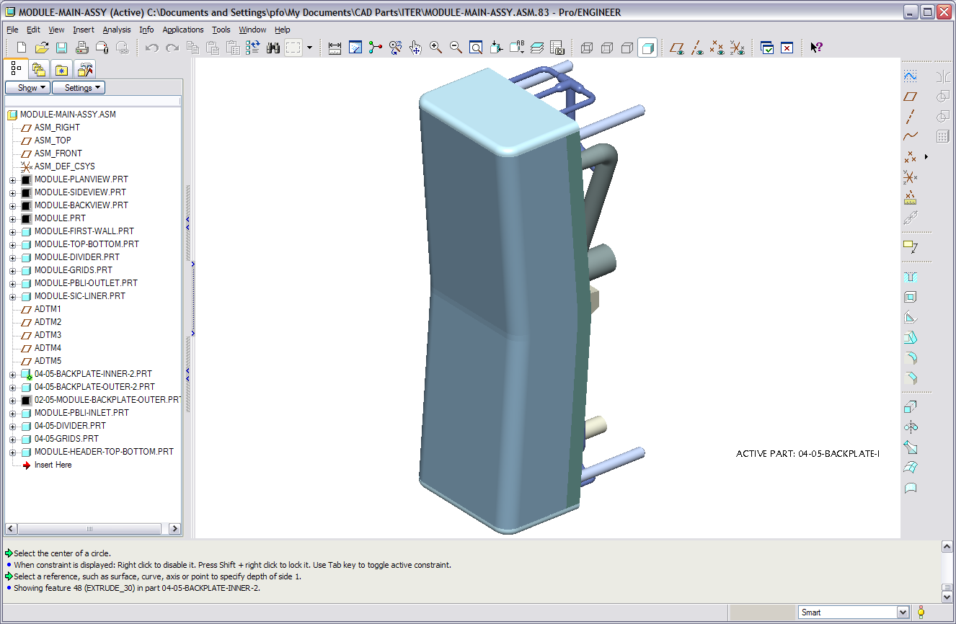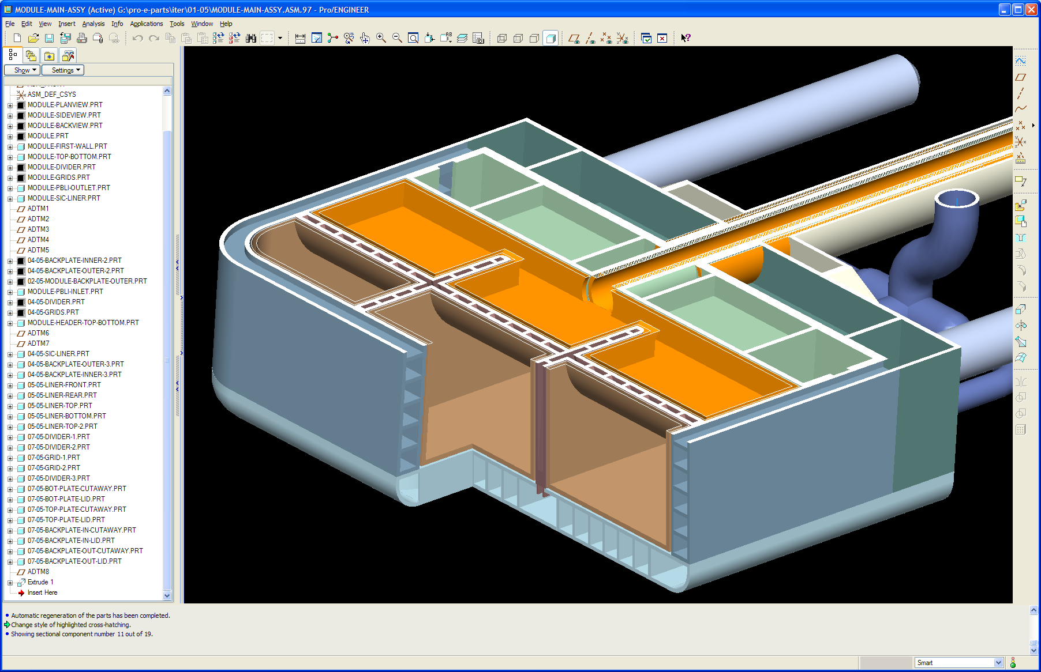
US DCLL TBM module
SS frame
Front
Back
Be front face
FS structure
FCI is the Thermal and MHD
Insulator lining all PbLi channels
He out
He in
PbLi in
PbLi out
All structures are He-cooled @ 8MPa
PbLi self-cooled flows in poloidal direction
PbLi in
PbLi out
FW He counter flow

Fig. 5 Relative location of the test module in the test port, transporter location and module cross-section sketch.

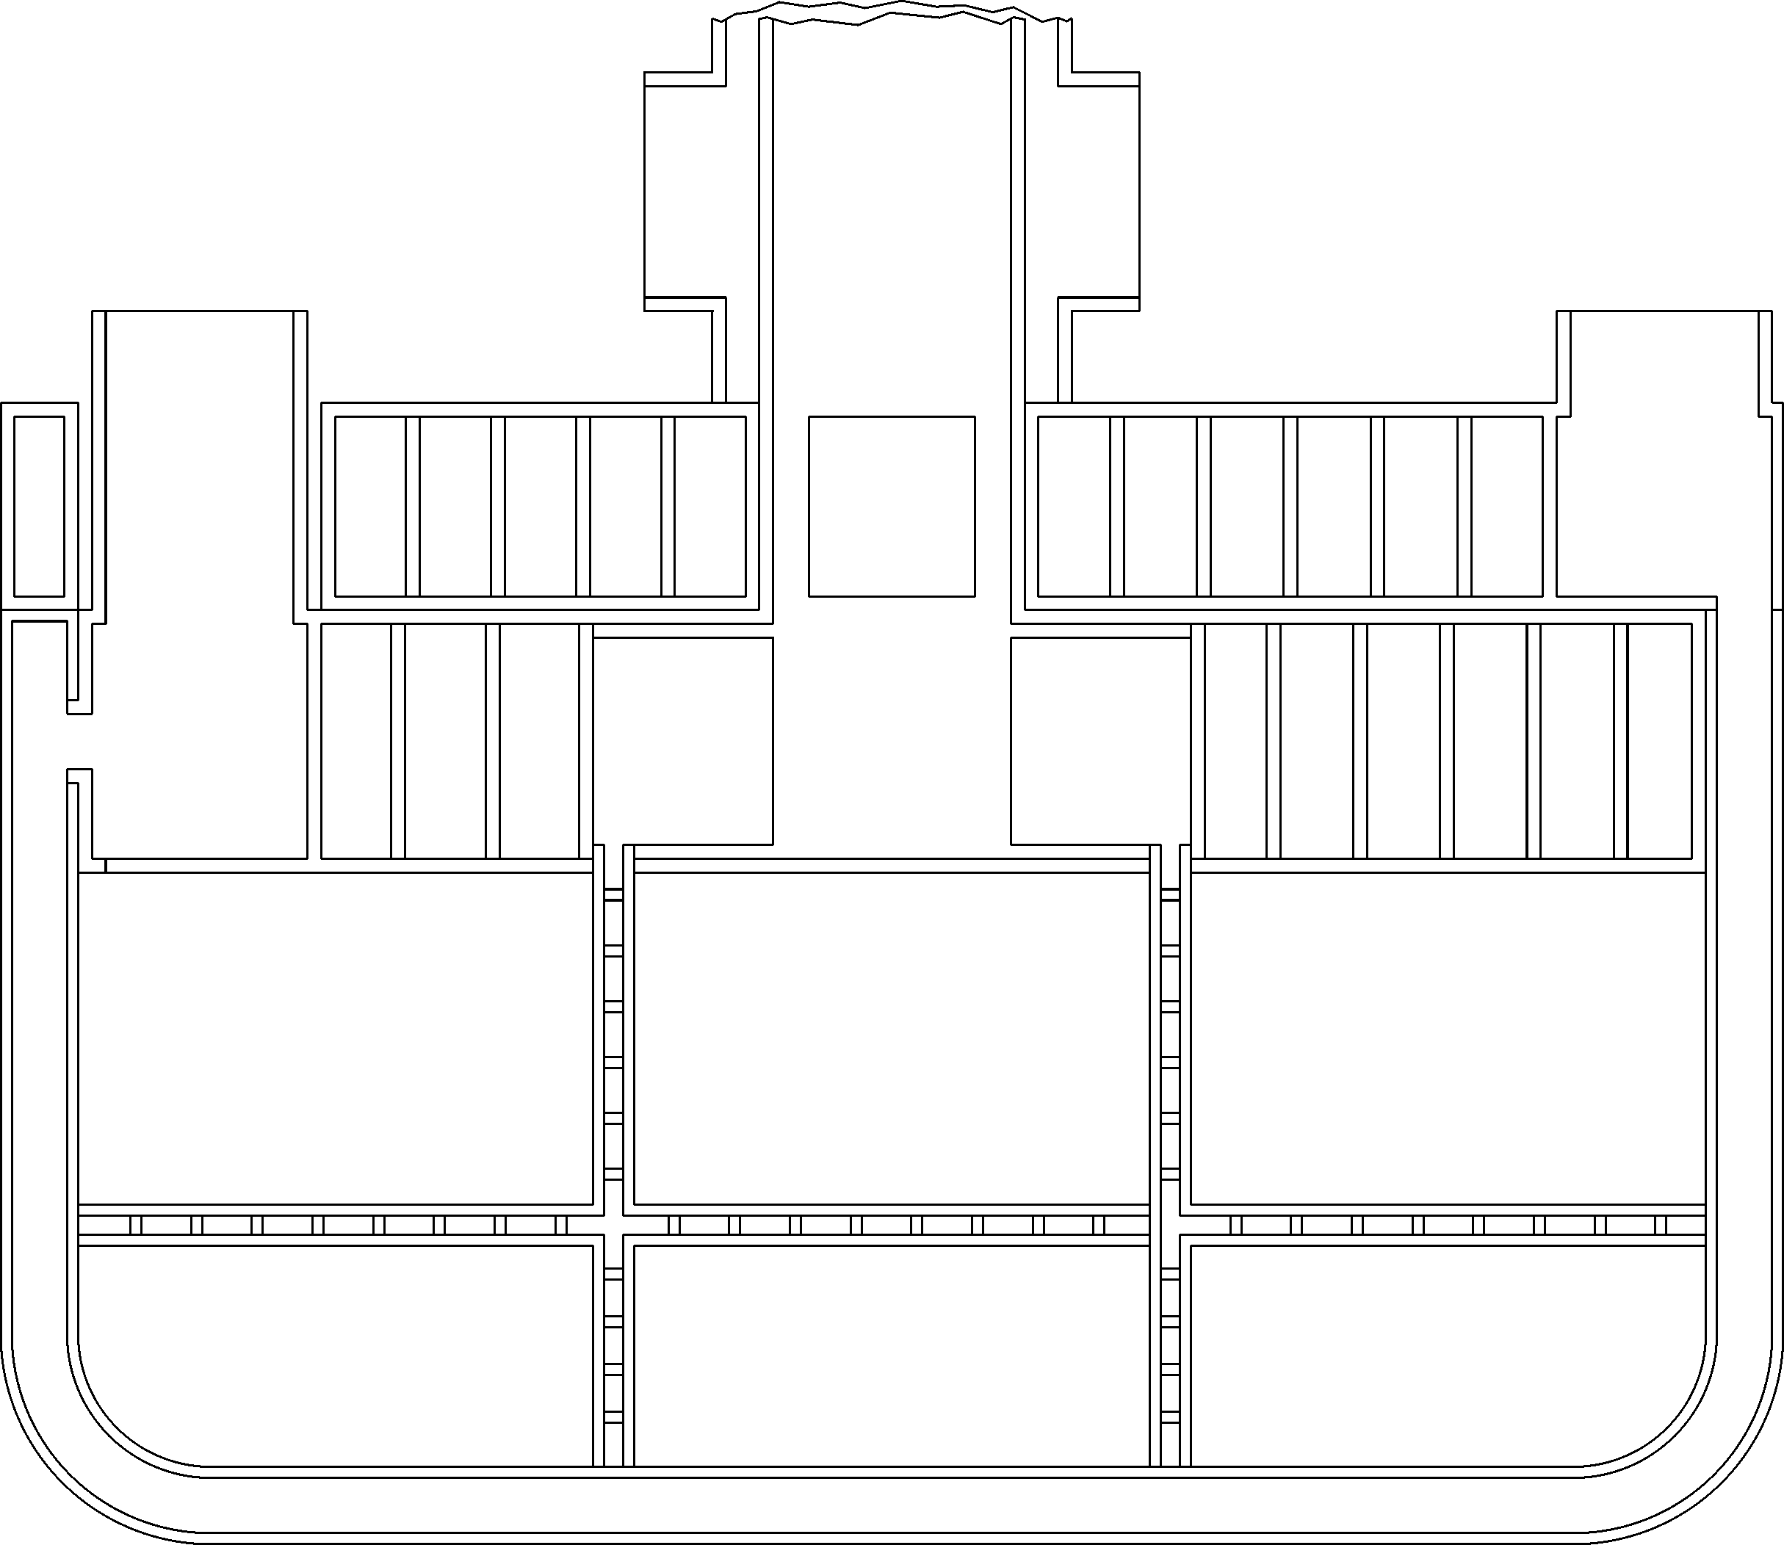
15
Divider
413
Module
Depth
28 First Wall
95
Inner Back
Plate
4
(typ wall)
20
(channel)
7
(channel)
120
PbLi
OUT
80
PbLi - IN
484 Module Width
Helium IN Plenum
First Wall
(Upper Channel)
Helium IN Plenum
First Wall
(Lower Channel)
139.3
(typ 3 places)
Helium OUT Plenums
(Top & Bottom Plates,
Grid Plates & Dividers)
15 Grid Plate
7 (channel)
75
Outer Back
Plate
Helium OUT
First Wall
Helium
IN
Helium
IN
All
Helium
OUT
5
(typ wall)
Back Plates
65
85
Helium flow channels
for actively cooling
The back plates
Dimensions in millimeters
Plan View
Blanket Module
68mm I.D.
Pipe Inlet
68 mm I.D.
Pipe Inlet

Fig. 6 Plan view of the DCLL module

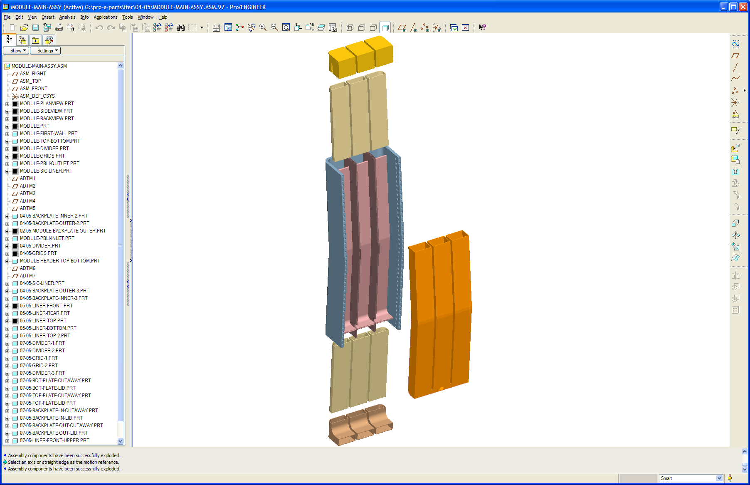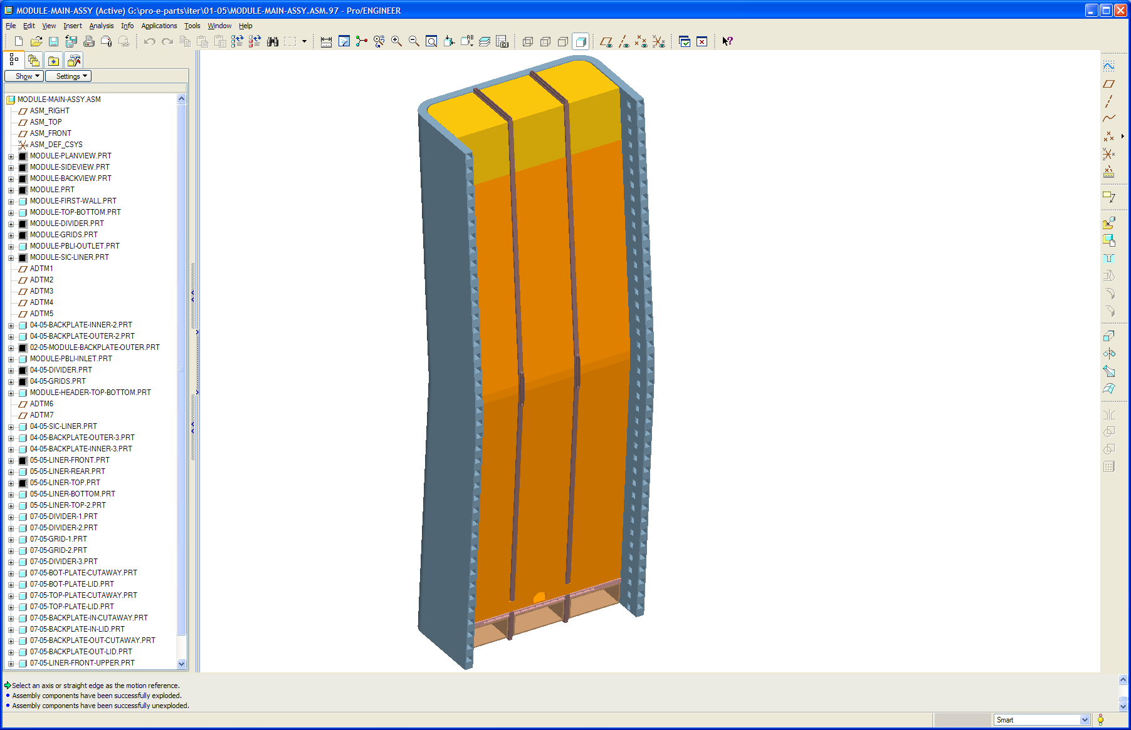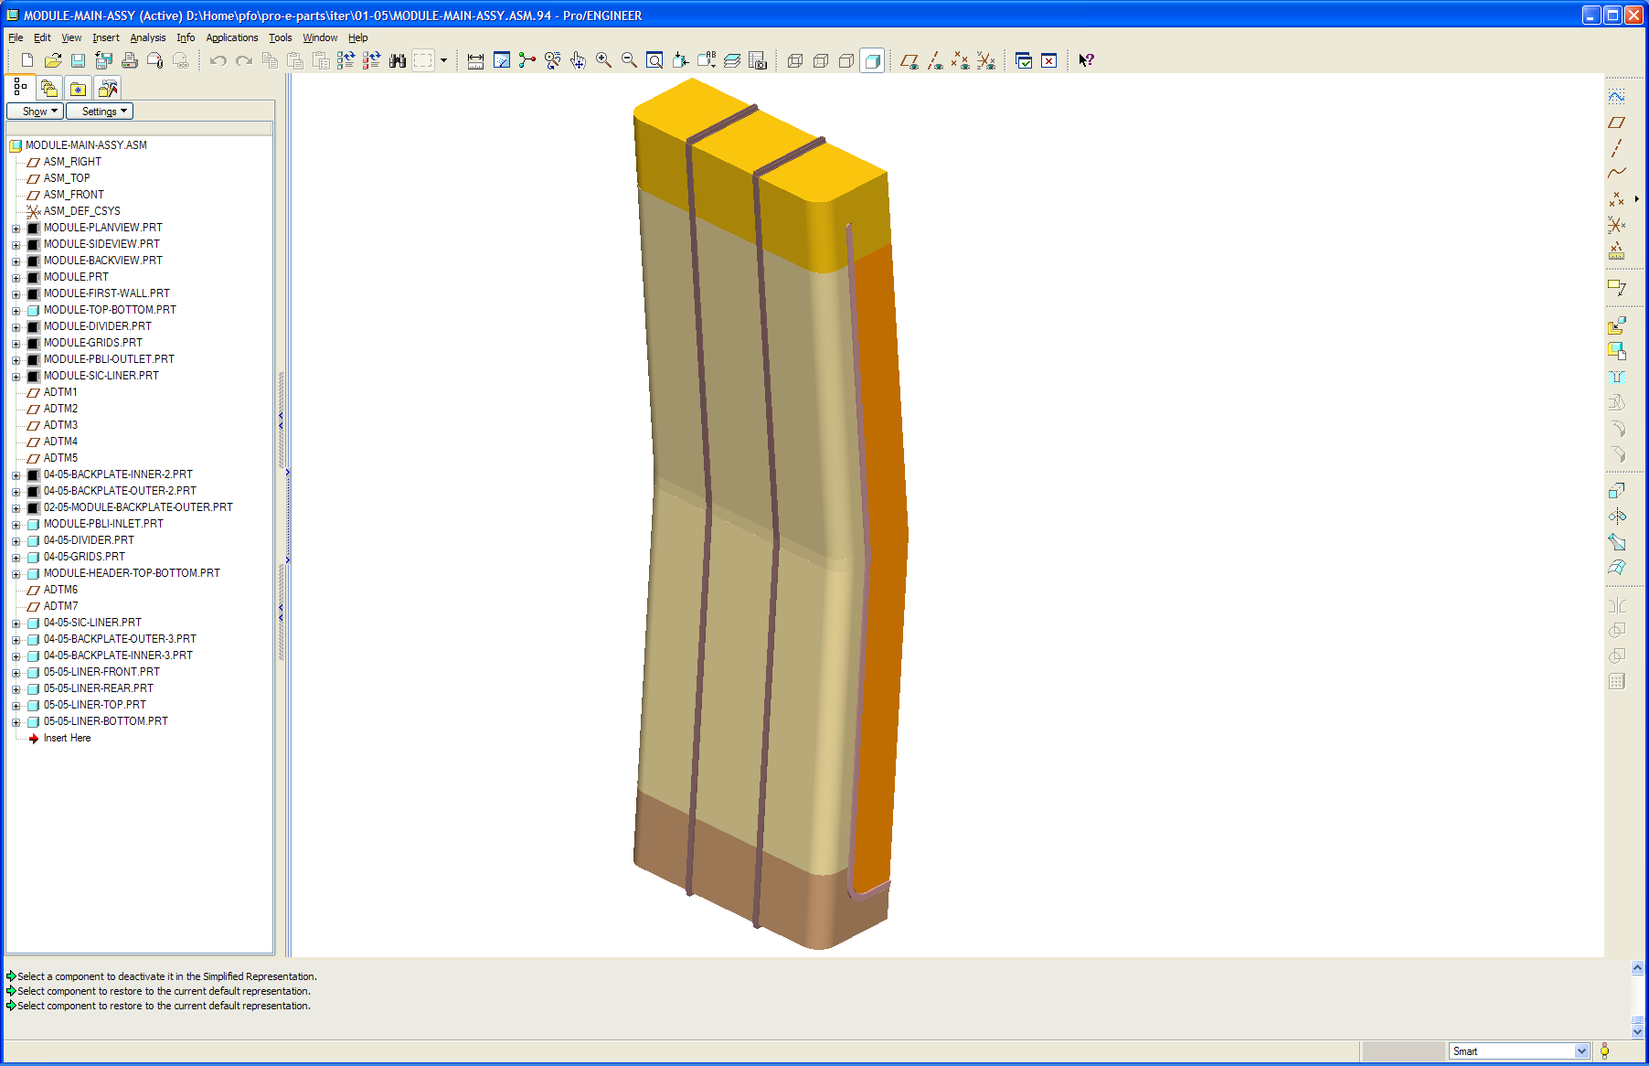
SiC Inserts
Front Upper
Assembly
SiC Inserts
Rear Assembly
SiC Inserts
Bottom Assembly
SiC Inserts
Top Assembly
Divider / Grid Plate
Assembly
Installation of SiC/SiC (FCI) inserts
SiC Inserts
Front Lower
Assembly
SiC inserts shown
assembled with the
first wall module
removed
SiC inserts shown
fully assembled in
first wall module
Front View
Back View

Fig. 7 Installation of SiC/SiC (FCI) inserts
4. Reference design operating temperatures

For the Reference DCLL TBM design we will be designing for the following temperature limits for the respective materials and material interfaces. We will design to these limits via configuration design and with the variation of the operating temperatures of the helium and PbLi coolants. For example, for the helium cooling of the first wall design we will have to use one-sided heat transfer enhancement to keep the first wall maximum temperature to meet the design limit of ferritic steel and with reasonable pressure drop.

TBM Reference design temperature limits

Ferritic Steel Tmin ≥ 300° C (due to DBTT)
Ferritic Steel Tmax ≤ 550° C
Ferritic Steel/PbLi interface Tmax < 500° C
SiC/PbLi interface Tmax < 500° C
SiC Tmax < 500° C

He and Pb-17Li operation temperature range

300° C < He < 440° C
300° C < PbLi ≤ 470° C

For the DCLL TBM design higher PbLi exit temperature > 470° C can be accommodated in a later phase of ITER operation, via the bypass loop as shown in Fig. 8 without requiring high-temperature materials for external piping heat exchangers and tritium extraction equipment. This can be achieved by turning the bypass valve “on” to allow mixing a lower temperature stream with the high-temperature stream in the Pb-17Li mixing tank. An example of such an operation is shown in Fig. 8.
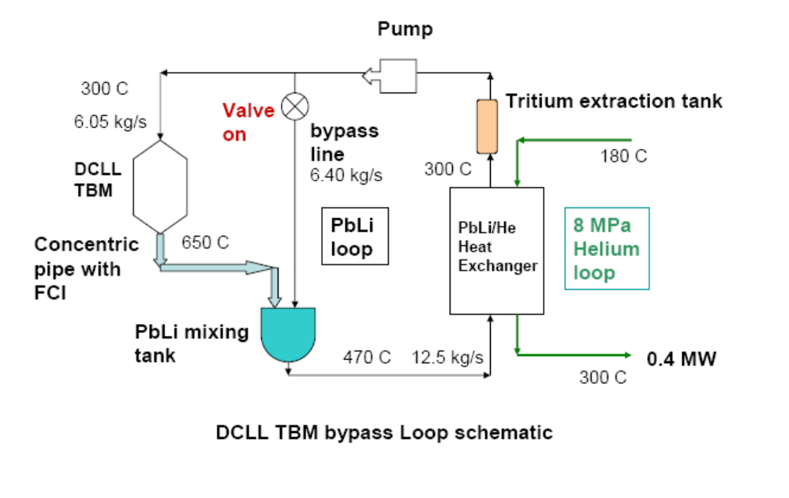
Fig. 8 DCLL TBM bypass loop schematic

5. Ancillary circuits and equipment

The DCLL ancillary equipment assessment [3] was based on the requirements of handling different operation/testing scenarios of the DCLL including the maximum FW heat flux and neutron wall loading from ITER. For the DCLL TBM system we have two coolant loops. The first one is the FW and structure helium coolant loop, which has a design point of carrying 54% (0.47 MW) of the total blanket power at the maximum ITER operation level. Dedicated helium piping is then designed between the TBM and the helium/water heat exchanger at the TCWS vault. The second loop is the liquid breeder loop that has a design point to carry 46% (0.4 MW) of the blanket power at the maximum ITER operating level. To avoid long liquid breeder pipes running from the TBMs to the heat exchanger in the TCWS, we decided to utilize a helium coolant intermediate loop. A liquid breeder-to-helium heat exchanger is located close to the test module on the transporter to minimize the amount of liquid breeder and the corresponding loss of tritium to the surroundings. In addition to the PbLi breeder loop located on the transporter, a helium intermediate heat removal loop/circuit with the same thermal capacity is used between the transporter and the TCWS water cooling system. Corresponding helium piping was also designed. The DCLL circuits are shown in Fig. 9. Key design parameters of the ancillary coolant loops are given in Table 5. The pumping capabilities of these loops are over designed to accommodate design flexibility of operating the testing components to lower temperatures than the point design.

Table 5 Key Ancillary Equipment Design Parameters of FW loop, PbLi loop, and Intermediate He loop. (The primary coolant pumping capacities (mass flow rate) are over-designed to allow flexibility in temperature control during different testing phases.)

Loop | 1 | 2 | 3
 | First Wall  Helium to Water | Liquid Breeder,  Pb-17Li to  Helium | Intermediate  Helium to Water
Thermal power, MW | 0.472 | 0.4 | 0.4
Primary coolant mass flow rate, kg/s | He @ 1.8 | PbLi @ 5.8 | He @ 2.2
Coolant Tin, C | He @ 300 | PbLi @ 300 | He @ 180
Pressure, MPa | 8 | 2 | 8
Number of circuits | 1 | 1 | 1
Secondary coolant | Water | Helium | Water
Secondary coolant Temperature at HX  in/out, ºC | 35/43 | 180/300 | 35/70
Pressure, MPa | Water <1 | He 8 | Water <1

Loop 1: Primary FW and structure helium loop between the TBM and the He/water heat exchanger located
in the TCWS vault.
Loop 2: Primary Pb-17Li loop between the TBM and the immediate Pb-17Li/He heat exchanger located on
the transporter.
Loop 3: Intermediate He loop between the Pb-17Li/He heat exchanger and the He/water heat exchanger located in the TCWS vault. (The heat exchanger design with Tin/Tout @ 180/300 C will have to
be revisited due to our lowering of the PbLi inlet temperature to 300 C for our Reference design.)

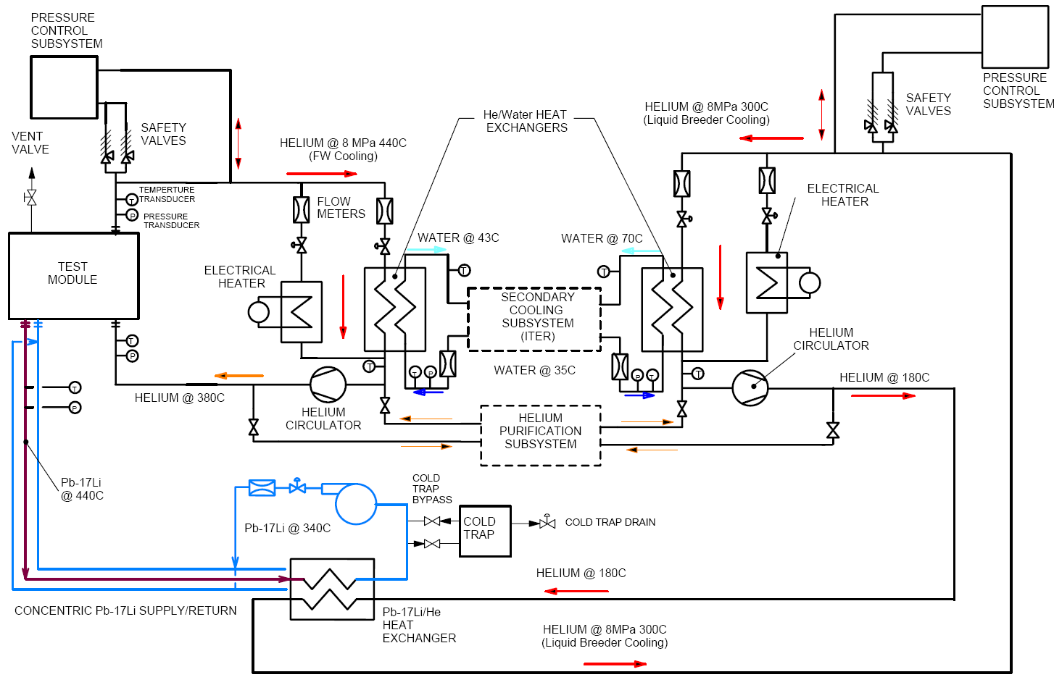
Pb-Li Primary Coolant Loop
Transporter, Port Cell Area
Secondary He Coolant Loop
TCWS
Test Port
Primary He Coolant Loop
TCWS

Fig. 9 DCLL TBM coolant circuits, Red-dotted circuit shows the primary He loop cooling the first wall and all FS structures, Blue-dash circuit shows the Pb-Li loop and the Green-dash circuit shows the secondary helium loop. (Note: Temperatures indicated are from earlier version of the design.)

The TBM is connected to the transporter through a series of pipes providing all the needed service mainly for cooling and diagnostics as shown in Fig. 10. These pipes must penetrate two barriers as they are routed between the transporter and the TBM. There are six pipes running between the transporter and the TBM. One concentric pipe carries the Pb-17Li breeder, with the hot liquid running in the inner pipe. The breeder energy is then transferred to two helium inlet and outlet pipes via the Pb-17Li/He heat exchanger. Two primary helium pipes carry the FW/sturcuture coolant in and out of the TBM. One drain pipe is used for draining the liquid from the TBM and the VV plug assembly prior to removal or in case of emergency. One purge line allows venting of gas or bubbles at the top of the module and a VV plug assembly prior to removal or in case of emergency. Arrangement of the PbLi circuit equipment located at the test port and the transporter are given in Fig. 10 and 11. Arrangement of the helium circuit equipment located at the TCWS vault, which is about 70 m away from the test port, is given in Fig. 12. The dimensions and weights of the components for the FW helium loop components are given in Table 6. For our costing exercise, these components and dimensions should also be applicable to the intermediate helium system since the power handling requirements for these loops are similar. The dimensions and weights of the components for the PbLi loop components are given in Table 7. As noted many of the entries in these tables are to be determined during the costing phase of our work.

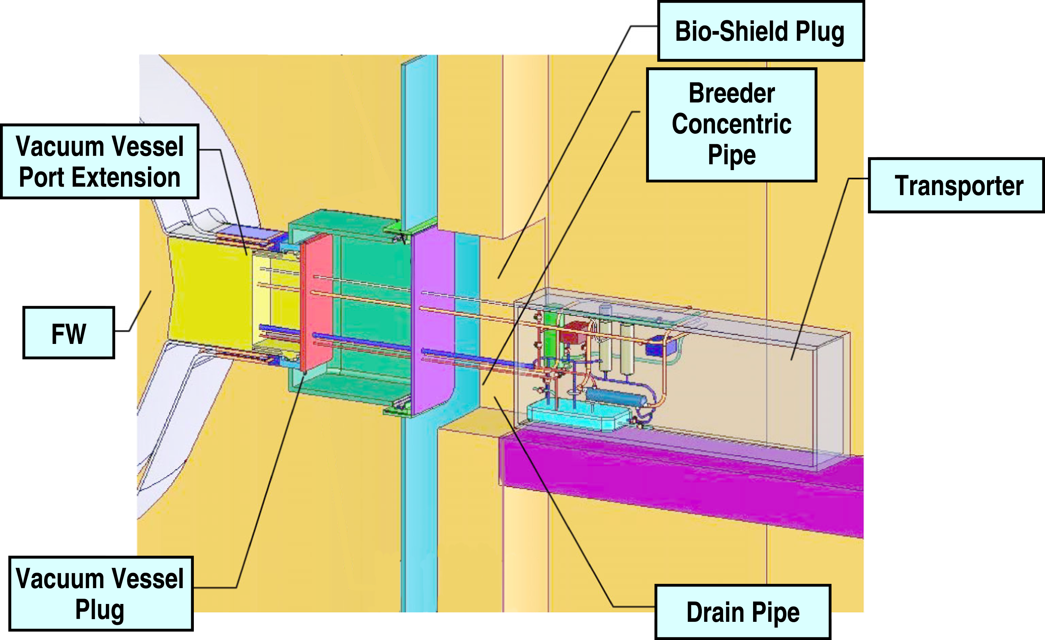

Fig. 10. Test port general arrangement.

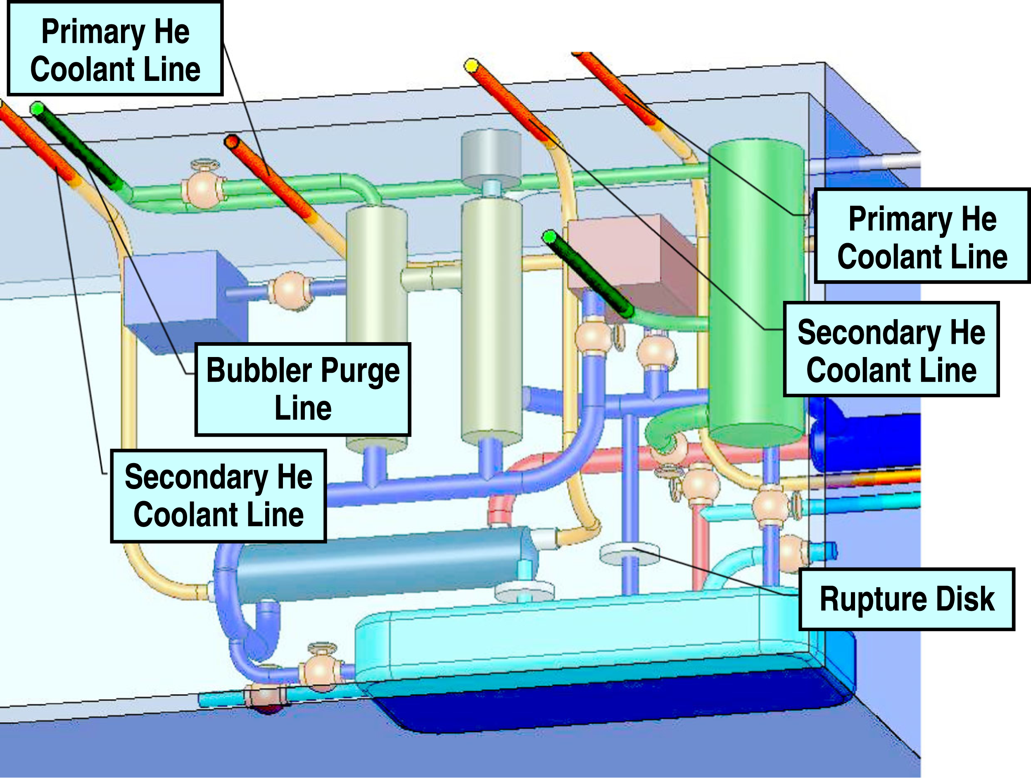

Fig. 11. DCLL TBM equipment in the transporter.

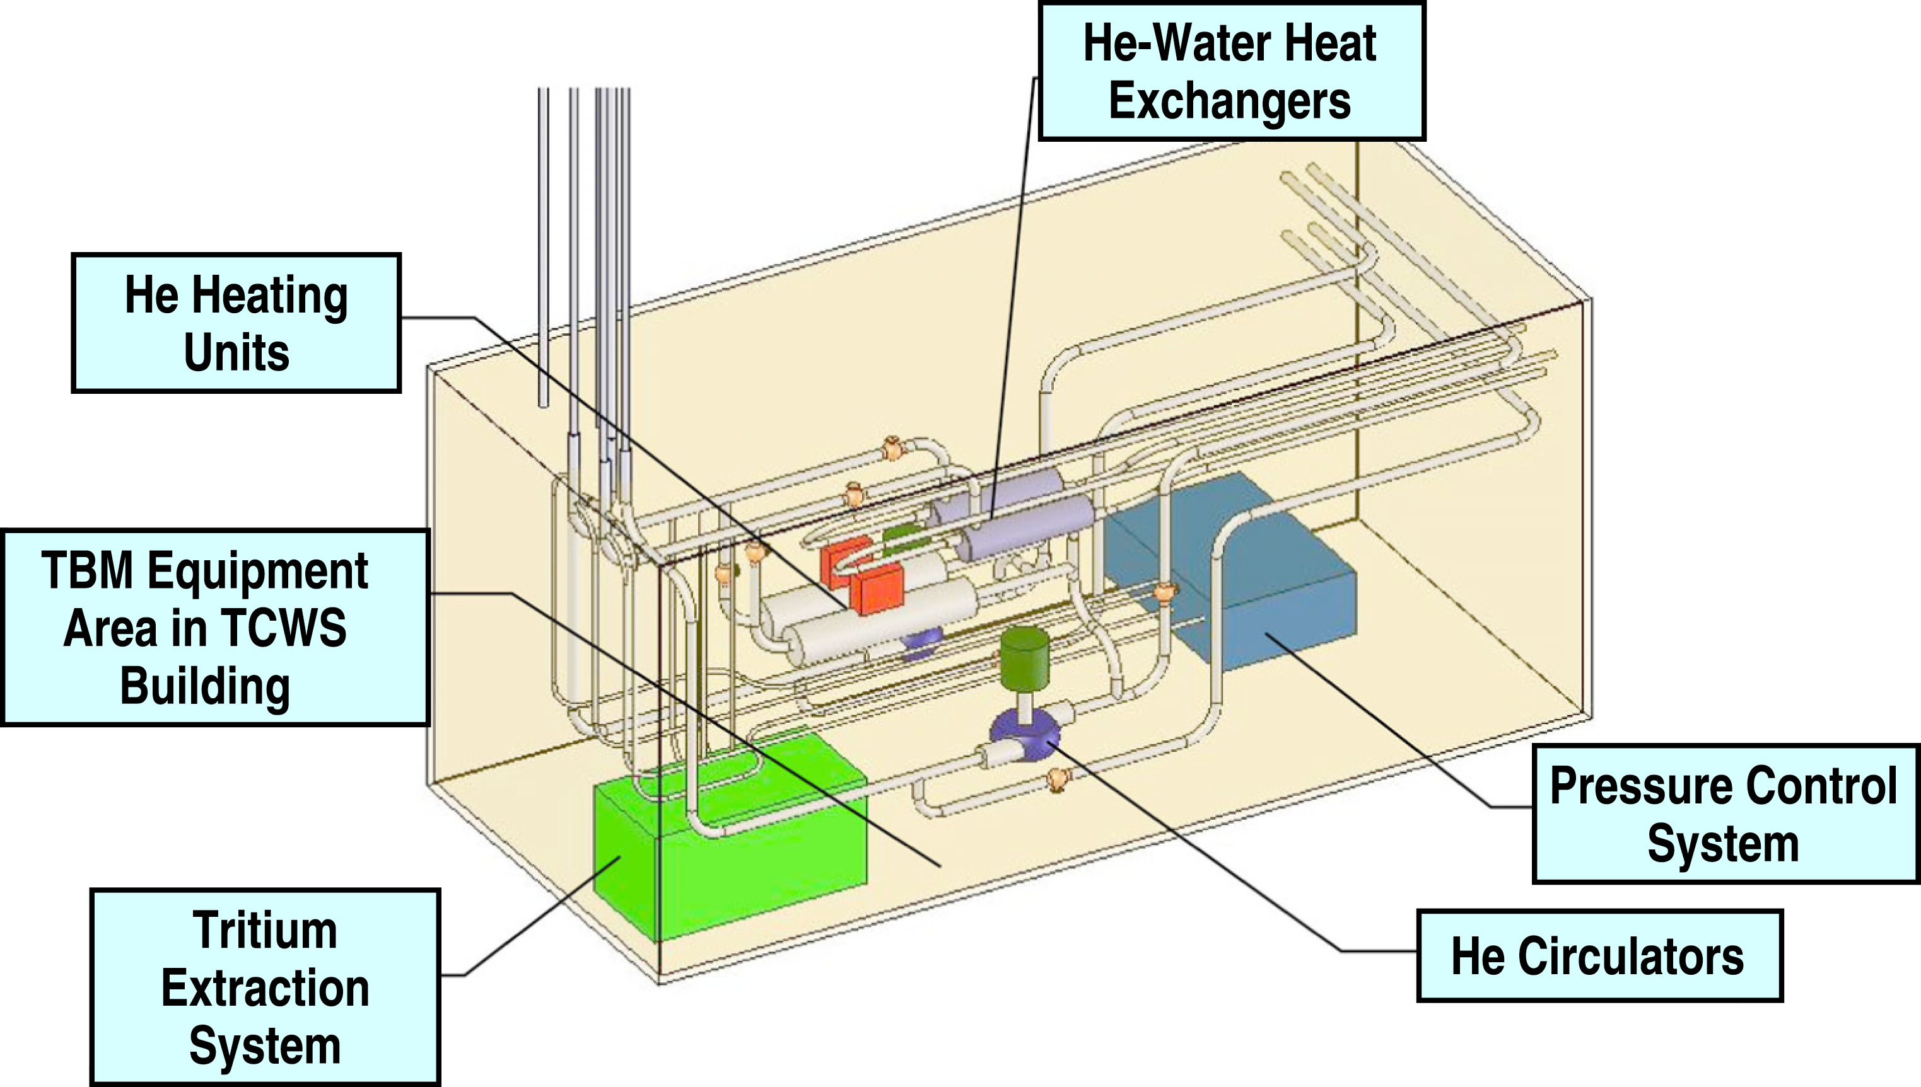

Fig.12. U.S. TBM primary and secondary coolant loops in TCWS.

Table 6 Dimensions and Weights of the key First Wall Helium Cooling Loop Components (Dimensions Not Including Thermal Insulation). Control and diagnostics systems will be added.

Component | Number | Diameter  (m) | Length  (m) | Weight  (kg)
Pipework (including bypass) | 1 | 0.1023 | 180 | 2959
Heat exchanger | 1 | 0.223 (o.d.) | 0.63 | 45.7
Circulator | 1 | 1.54 | 0.30 | 1979
Circulator motor | 1 | 0.88 | 1.46 | 1670
Electrical heater | 1 | 0.35 | 1.65 | 287
Helium storage tanks | 9 | 0.4 | 2.6 | 4808
Helium dump tanks | 4 | 0.4 | 2.6 | 2137
Buffer tank | 1 | 0.4 | 2.6 | 534
Total weight |  |  |  | 14420

Table 7 Dimensions and Weights of the PbLi Loop Components (Dimensions Not Including Thermal Insulation). Control and diagnostics systems will be added. Our design goal is to have the total Pb-17Li inventory to be ≤ 0.27 m³.

Component | Number | Diameter (m) | Length, (m) | Weight, (kg)
Pb-Li pump | 1 | 0.25 | 1
Pump housing and expansion tank | 2 | 0.25 | 1
Pump motor | 1 | TBD | TBD
Pb-Li mixing Tank | 1 | TBD | TBD
Pb-Li/He heat exchanger | 1 | 0.37 | 2.4
Pb-Li/Tritium Extraction System* | 1 | 1 | 2
Pb-Li dump tank | 1 | 1 x 1 | 0.5
Dump tank heater | 1
Pressure control unit | 1
Cold trap for PbLi | 1
Cold trap coolant | 1
Bi extraction system | 1
Po extraction system | 1
Pb-Li Concentric Pipe | 1
Pb-Li Loop Piping | 1
Trace heaters | TBD
He loop Piping | TBD
Test module | 1
Total weight

Reference

[1] U.S. TEST BLANKET MODULE (TBM) PROGRAM IN ITER, to be distributed, September, 2005.

[2] TBWG Final Report, Chapter 2. “ITER Boundary Conditions & Testing Parameters.” July, 2005.

[3] C.P. Wong, M. Abdou, D.P. Carosella, M. Dagher, M.P. Labar, S. Malang, B.Merrill, N. Morley, M. Sawan, R.S. Willms, D-K Sze, Ancillary systems for dual coolant liquid breeder test blanket modules – Interim report to the ITER Test Blanket Working Group (TBWG), UCLA-FNT-195, General Atomics Report GA–A24754, 2004.

Appendix

A1 ITER operating schedule
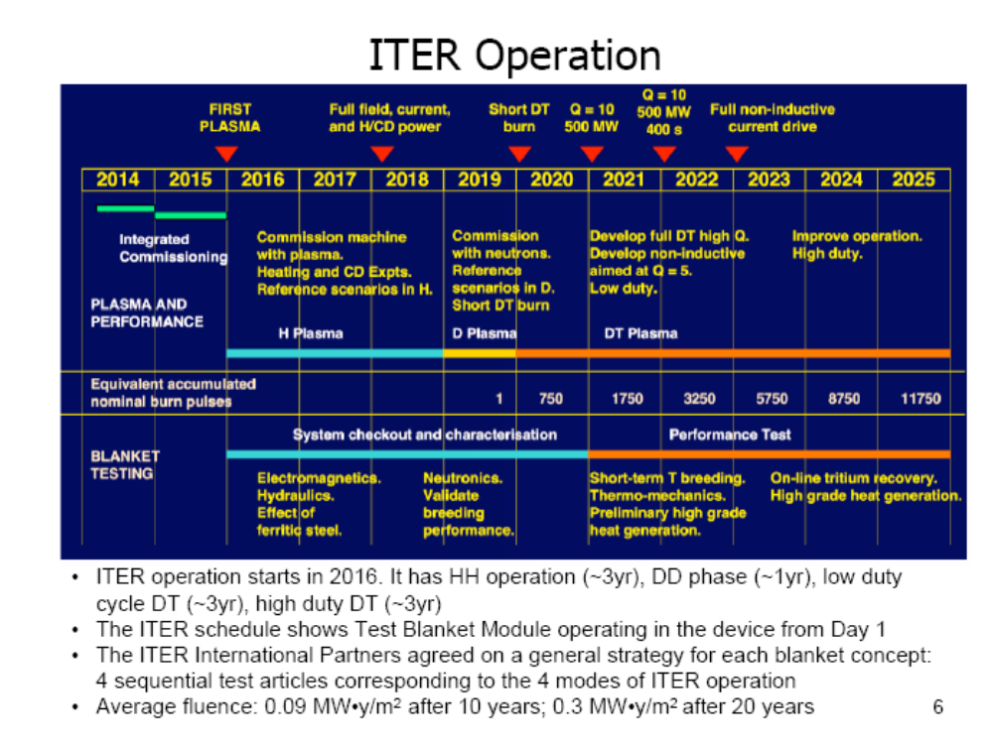
Fig. A1 ITER operation schedule
A2. DCLL test plan

Table A1 DCLL TBM test plan

 | Experimental Goals | ITER Phase / Duration
1st TBM  EM / Structural | - Validate general DCLL TBM Structure and FCI response to EM/Plasma environment  - Establish system performance baseline and operation experience prior to nuclear operation  - Perform initial studies of MHD effects in ITER fields | HH  for  3 years
2nd TBM  Nuclear Field/ Tritium Production | - Neutron field measurements database for various types of ITER discharges and conditions  - Measure tritium production rate (TPR), and nuclear heating rates  - FW He cooling validation at full load  - Tritium implantation effects | DD +  Early DT  for  2 years
3rd TBM  Thermofluid / MHD | - Thermal and electrical insulation properties of the FCI and FCI failure effects  - Tritium permeation through FCIs  - Velocity measurements with FCI gap flow and natural convection  - Initial data on activation products and chemistry control | Low duty DT for  2 years
4th TBM  Integrated | - Investigate high temperature TBM operation including flow channel inserts behavior, effect on tritium permeation and corrosion and activation products  - Investigate online tritium recovery from PbLi and He streams  - Investigate online PbLi purification systems  - Explore longer term Integrated operation of the system including small accumulation of radiation damage in FCIs and RAFS joints | High duty DT  for  3 years

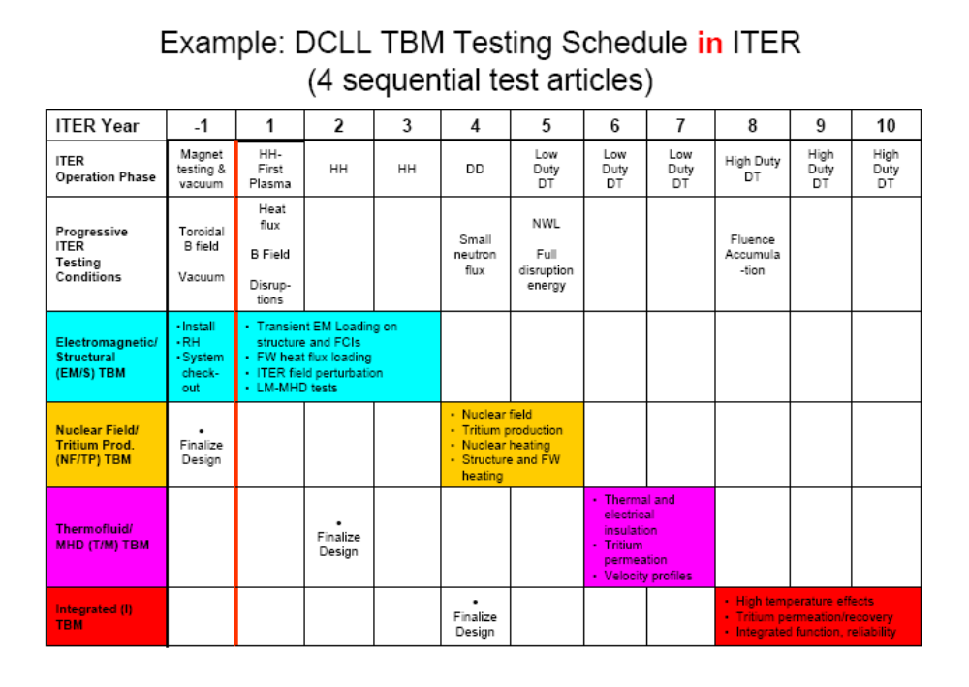

Fig. A2 DCLL TBM test plan.

A3. Detailed heat loads for the ITER DT phase

Table A2. Heat loads conditions during D-T Phase for Test Blanket Modules [2] (This table is copied from reference 2, and no editing has been made.)

Parameter | Design values for test blanket module | Comments | Basis
Inductive operation Fusion power; 500 MW, Burn time 400 sec
Heat flux during burn time in normal plasma operation | 0.27 MW/m²  3,000 cycles (equivalent nominal pulses) per year | It is preferable that the test blanket module (TBM) withstands 0.5 MW/m² 3,000 cycles per year to maintain an adequate design margin, where the design value for the FW in general is 0.5 MW/m² 30,000 cycles for the whole ITER life. | ⁽Radiation Loss:136MW / (680 m² x 1.06) x 1.41 (peaking factor: TBD) = 0.27 MW/m²
Fusion Power Excursion | 0.30 MW/m² Duration 10 sec  1,000 cycles | Fusion power excursion: +20%⁽ will increase the radiation loss by 10-15 %. | Total Radiation Loss: (100 MW x 1.2 + 73 MW) x 1.05 x 0.75 = 152MW instead of 136MW. This gives 0.30 MW/m²
Surface heat flux due to MARFE or other phenomena | 0.5 MW/m^{2 (*)}  Steady-state (in a localized region^{(*)})  100 cycles  per year | MARFE (Duration; 10 sec) in the outboard region has a small probability.  When MARFE is detected, the plasma will be shut-down.  The heat load due to other phenomena can be steady-state, but the high heat load is localized.. | Estimation is based on a private communication (A Kukushkin)  ^{(*)} In the case of steady -state condition, the average heat load in TBM is not more than 0.3 MW/m² (the average can be for the TBM overall, or in the toroidal or poloidal direction ).
Disruption heat load | TBM is recessed: 0.55 MJ/m²  Duration 1 ms  300 cycles per year | Peak energy deposition is defined to be 0.36 MJ/m² in the present DRG1. However, according to recent data (JET,ASDEX-U), the maximum heat load on the FW can be higher. DRG1 will be updated.. | 350MJ x 0.8* / (680 m2 x 1.06) x 1.4 (peaking factor) =0.55 MJ/m²  *~80 % of the thermal energy can go to the FW at maximum. (Experimental data in JET and ASDEX-U)
Disruption heat load during current quench | 0.72MJ/m²  Duration 40 ms  300 cycles per year | All of the internal magnetic energy is assumed to be radiated with peaking factor 1.4. | 370MJ / (680 m2 x 1.06) x 1.4 (peaking factor) =0.72 MJ/m²
Heat load due to ELM and "blob" | Negligible (TBD) | The heat load due to ELM and "blob" will be negligible, considering the distance from the separatrix and recess of the TBM FW locations. | The heat load conditions due to these effects might be revisited based on additional experimental data in the future.
Neutron wall load on TBM FW | 0.78 MW/m² | Average neutron wall loading is 0.56 MW/m², and the local neutron wall loading in the outboard equatorial port region is 0.78 MW/m²
Pulse length | Typical case;  400sec (burn time)  1800 sec (repetition time)
Duty factor | Peak burn duty factor: 0.25
Non-inductive operation Fusion power 356 MW, Burn time 3,000 sec
Heat flux during burn time in normal plasma operation | 0.20 MW/m²  Duration 3,000 sec  TBD cycles (equivalent nominal pulses) per year | From thermal fatigue point of view, this condition will be less severe than Reference Case. | ⁽Radiation Loss:(71+59)MW x 1.05 x 0.75 = 102.4 MW instead of 136MW. This gives 0.20 MW/m²
Fusion Power Excursion | 0.23 MW/m² Duration 10 sec  TBD cycles | Fusion power excursion: +20% will increase the radiation loss by 10-15 %. | RadiationLoss: (71x1.2+59)MW x 1.05 x 0.75 = 113.6 MW instead of 136MW. This gives 0.23 MW/m²
Surface heat flux due to MARFE or other phenomena | 0.5 MW/m^{2 (*)}  Steady-state (in a localized region^{(*)})  100⁽⁴⁾ cycles  per year | MARFE (Duration:10 sec) in the outboard region has a small probability.  When MARFE is detected, the plasma will be shut-down.  The heat load due to other phenomena can be steady-state, but the high heat load is localized.. | ^{(*)} In the case of steady -state condition, the average heat load in TBM is not more than 0.3 MW/m² (the average can be for the TBM overall, or in the toroidal or poloidal direction ).
Disruption heat load | TBM is recessed: 0.45 MJ/m²  Duration 1 ms |  | 287 MJ (instead of 350 MJ) gives 0.45 MJ/m²
Disruption heat load during current quench | 0.26MJ/m²  Duration 24 ms | All of the internal magnetic energy is assumed to be radiated with peaking factor 1.4. | 133MJ / (680 m2 x 1.06) x 1.4 (peaking factor) =0.26 MJ/m²
Heat load due to ELM and "blob" | Negligible (TBD) | Same as above
Neutron wall load on TBM FW | 0.56 MW/m² | The wall loading is proportional to the fusion power. Average neutron wall loading is 0.40 MW/m², and the local neutron wall loading in the outboard equatorial port region is 0.56 MW/m²
Pulse length | Typical case;  3000 sec (burn time)  12000 sec (repetition time)
Duty factor | Peak burn duty factor: TBD

