OVERVIEW OF ADVANCED FUSION SCIENCE AND TECHNOLOGY PROGRAM AT UCLA

Professor Mohamed Abdou

N. Morley, A. Ying, K.Gulec, M. Youssef, T. Sketchley

Presentation to Dr. Anne Davies, Director OFES

January 26, 1999

Advanced Fusion Science and Technology Program
Prof. M. Abdou

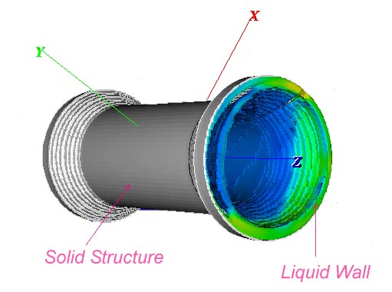
Innovative Chamber Technologies that can dramatically improve the vision of an attractive fusion energy product

FRC Chamber with Liquid Wall

Alternative Uses of Fusion: Space Propulsion, Waste Transmutation
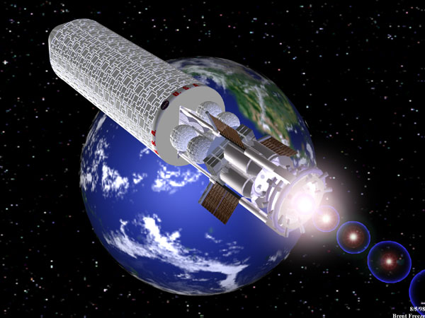
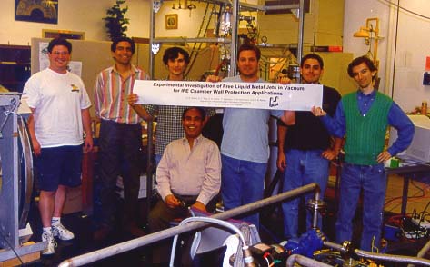
MTF Propelled Rocket
MeSO-Jet Research Staff and Students
Basic Science Research in the
physical and engineering sciences
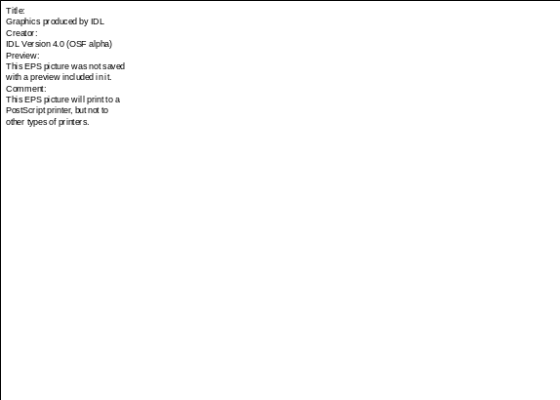
Simulation of Ablation Shocks in Thin Liquid Walls for IFE Reactors

Training Students as
future fusion scientists

Duel Research Goals:
Developing Fusion Energy Technology and
Advancing State of Fusion Sciences

Example: Liquid Walls

APEX Liquid Walls | Basic Science Fields
- Liquid Wall Formation and Configuration Feasibility | - Turbulent Hydrodynamics  - Laminar Magneto-hydrodynamics  - Contact Discontinuity Tracking
- Liquid Surface Temperature and Evaporation Flux | - Turbulent Heat Transfer in High Prandtl Number Free Surface Flow  - Laminar MHD Heat Transfer in Low Prandtl Number Free Surface Flow  - X-Ray Photon Transport in Low Z Liquids
- Plasma Edge Shielding of Evaporated Impurities | - Neutral Transport and Ionization in Plasma Background  - Edge Plasma Physics
- High Temperature Liquid Wall Operation | - Corrosion Chemistry  - Material Interactions
Research Approach:
Sophisticated Numerical Simulations with
Scaled Laboratory Experiments

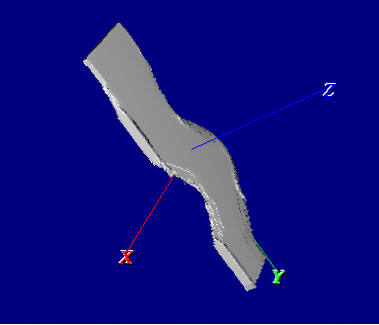
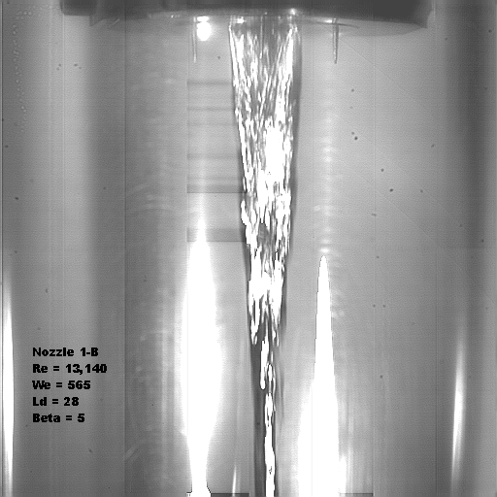
Example: Liquid Jets for IFE Chambers

3D Computer Simulation of Oscillating Jet 2mm×10mm Stationary LM Jet Experiment
Take Advantage of Facility and Modeling
Synergism between MFE and IFE Chambers

Example: Modeling Advanced FRC Chamber with Liquid Walls
and Innovative HIF Cylindrical-Cusp Chamber
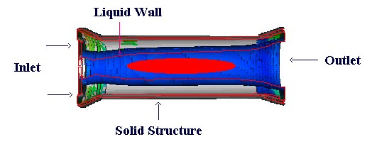
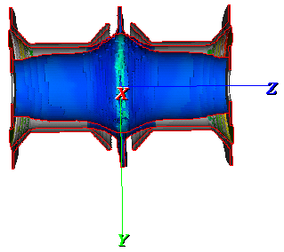
U_{θ}
U_{z}
U_{θ}
U_{z}
Cylindrical FRC
Cusp HIF
Advanced Fusion Science and Technology Program

Research Projects

- APEX and ALPS
- IFE Chamber Development
- Non-Structural Material Interactions

Fusion Rocket Propulsion
- Structural Material Research

Liquid Wall Research for MFE

Concept: Replace first wall, blanket and shield with a thick flowing liquid
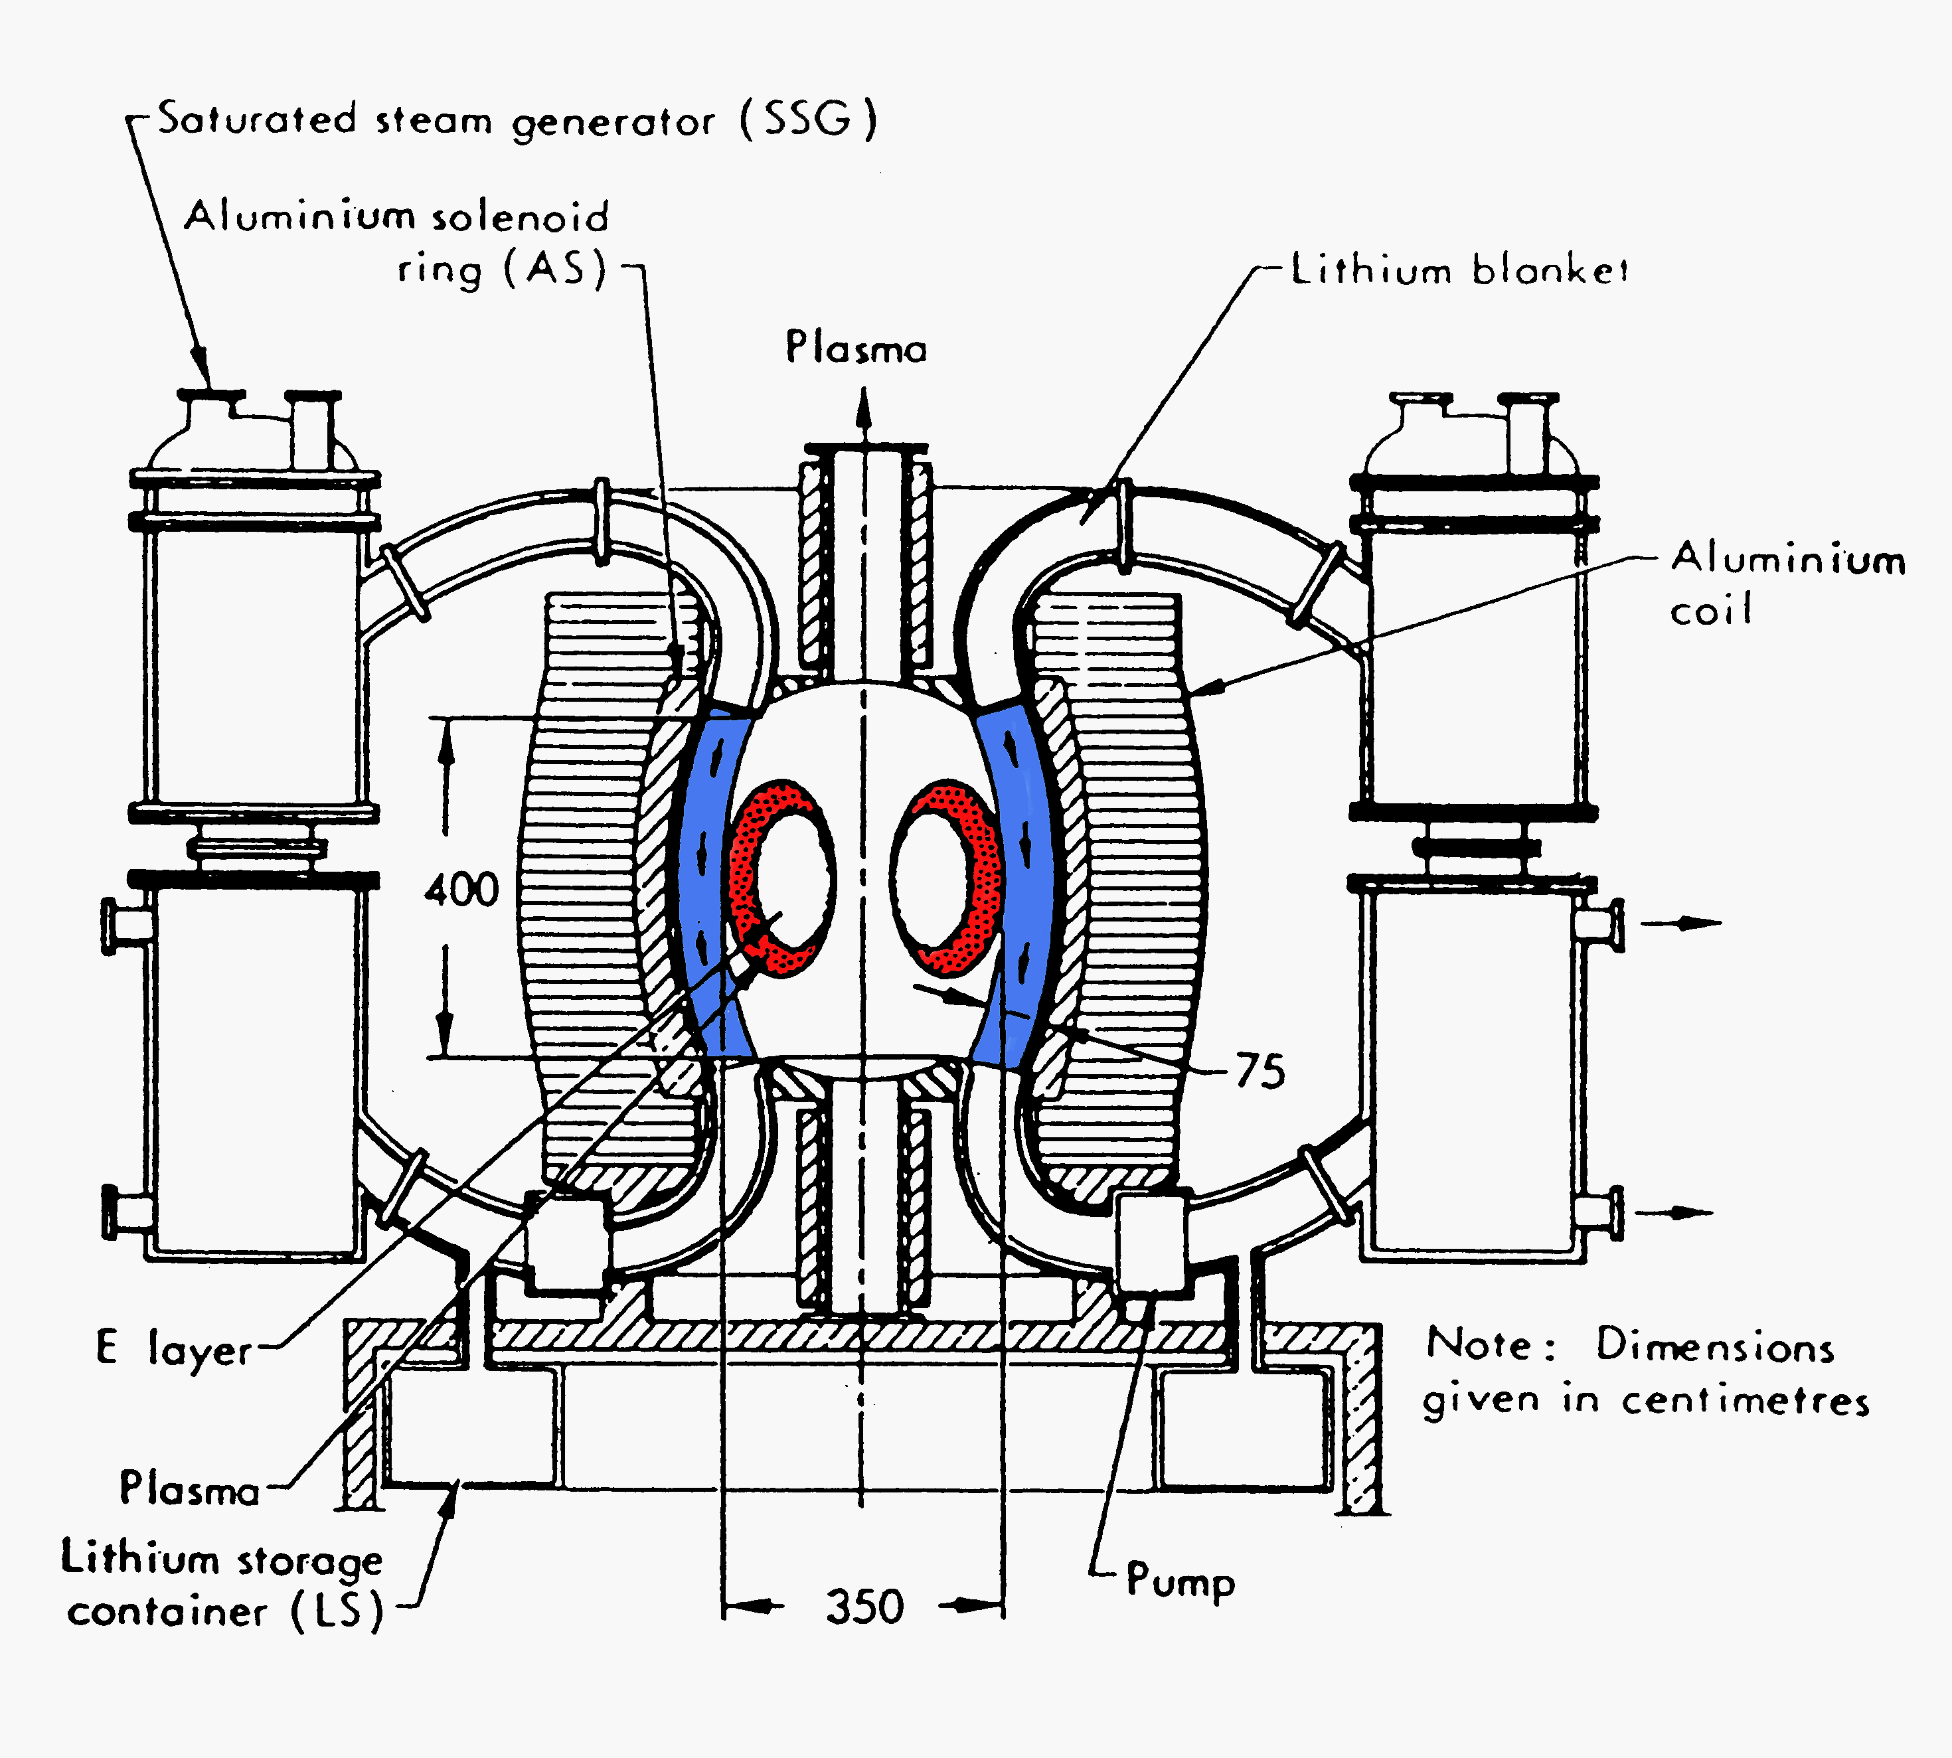
Advantages:
- Replenishable surface facing plasma
- Surface heat transfer directly to coolant, higher average coolant temperature
- Elimation of solid first wall and blanket thermal stress driven failure modes.
- Elimination of significant neutron damage and activation

Implications for Fusion Product:
- Higher Power Density
- Higher Thermal Efficiency
- Higher Reliability
- Easier Maintanance
- Reduction of radioactive waste

Convective Liquid Flow First wall (CLIFF) Concepts

- Underlying structure protected by a fast moving layer of liquid, typically 1 to 2 cm thick at 10 to 20 m/s.
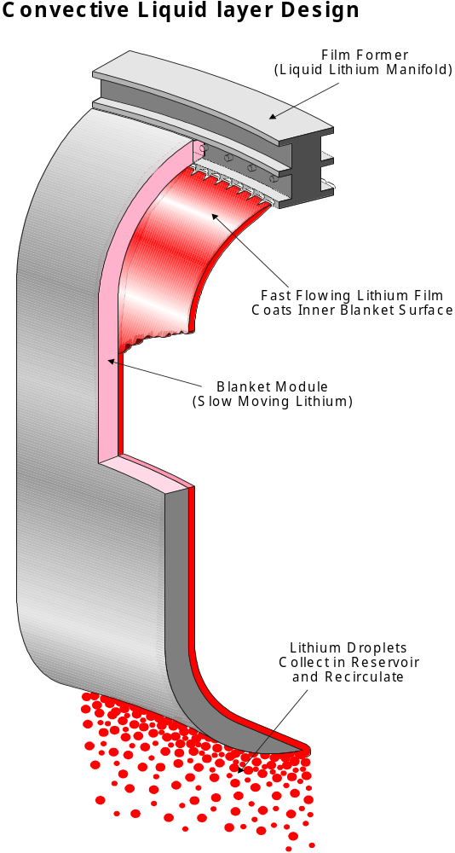

- Conventional or more innovative liquid breeder blanket located directly behind the CLIFF-wall

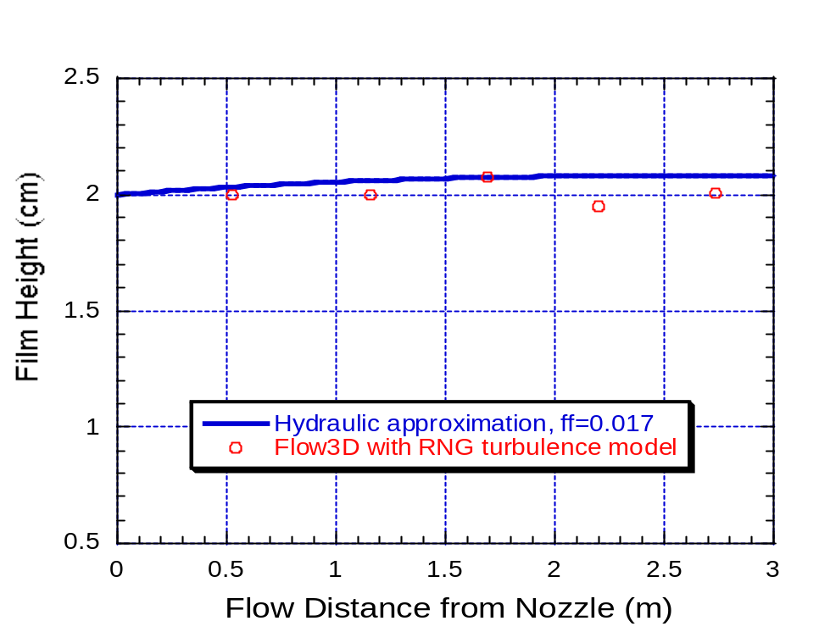
- 2D hydrodynamic calculations confirm near equilibrium flow for Flibe at 2 cm depth and 10 m/s velocity (below)
2D Analysis of FW Flibe flow

Gravity-Momentum Driven Thick Liquid Wall Concept

- Utilize mechanically isolated recirculating pockets of liquid Flibe
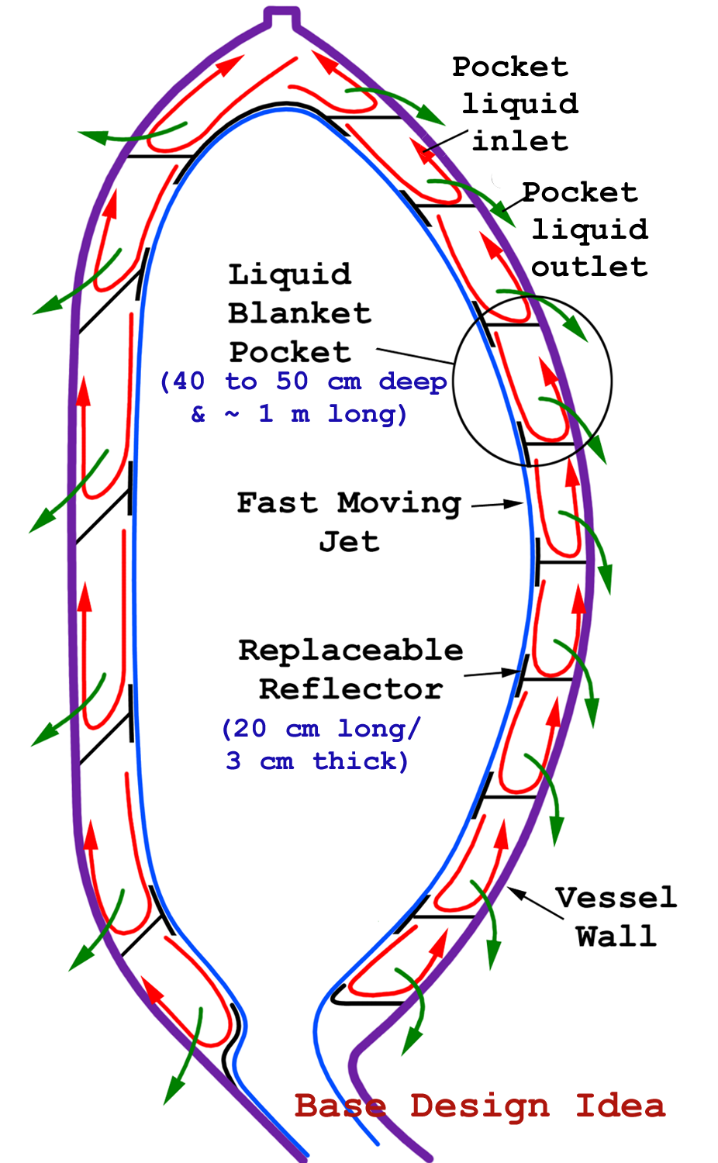
- Fast liquid layer covers pocket and mechanical “reflector” surface

Reflectors are easily replaceable
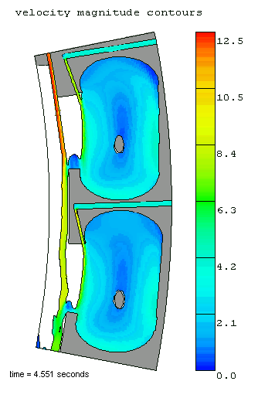

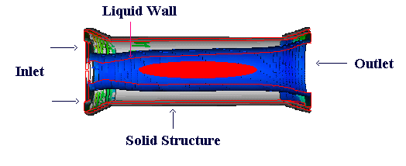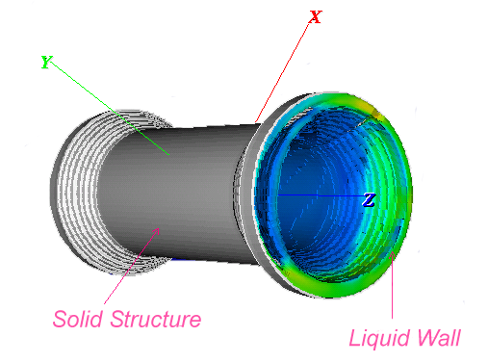Swirling Thick Liquid Walls for High Power Density FRC
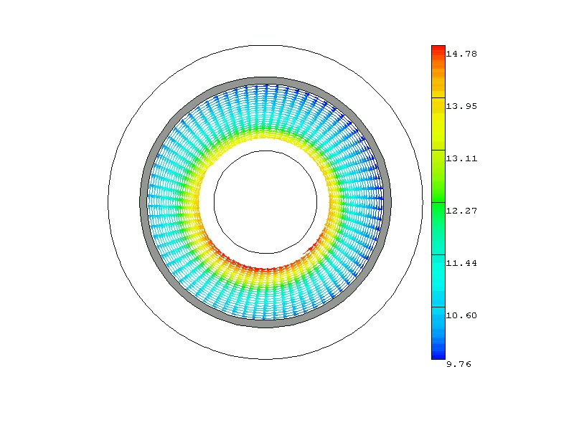
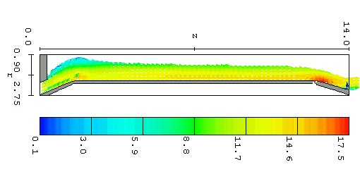
- Design: Horizontally oriented structural cylinder with a liquid vortex flow covering the inside surface. Thick liquid blanket interposed between plasma and all structure

- Computer Simulation: 3-D time-dependent Navier-Stokes Equations solved with RNG turbulence model and Volume of Fluid algorithm for free surface tracking

- Results: Adhesion and liquid thickness uniformity (> 50 cm) met with a flow of V_{axial} = 10 m/s, V_{θ,ave} = 11 m/s

Calculated velocity and surface depth

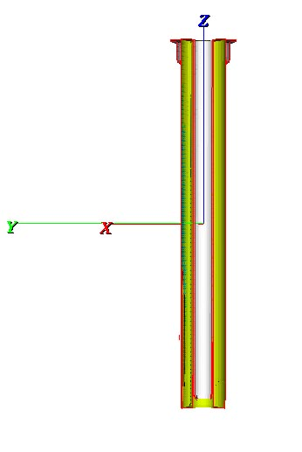
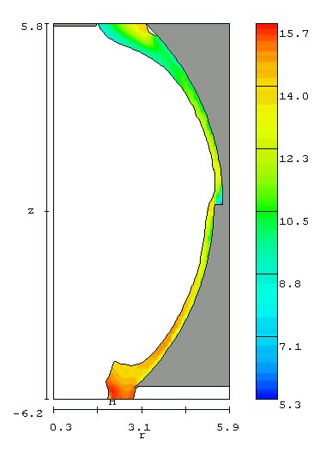
Toroidally Rotating Thick Liquid Wall for the ST
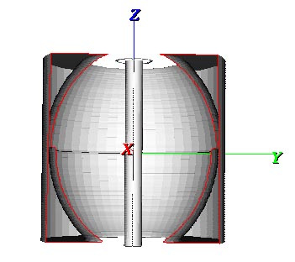
Simulation Results:

- Step in outboard vacuum vessel topology helps maintain liquid thickness > 30 cm

- Calculated outboard inlet velocity,
V_{poloidal} = 4.5 m/s, V_{toroidal,ave} = 12 m/s

- Inboard jet V_{z} = 15 m/s is high to prevent excessive thinning, < 30%

Design Concept:

- Thick liquid flow from reactor top

- Outboard: Fluid remains attached to outer wall due to centrifugal acceleration from the toroidal liquid velocity

- Inboard: Fast annular liquid jet

IFE Chamber Phenomena Research:

Analysis, Modeling and Experiments for

Liquid Wall Protection and Chamber Clearing Schemes

Mohamed A. Abdou

University of California, Los Angeles

Objectives and Strategy
- Understanding the relevant phenomena and underlying science of challenging IFE chamber physics and engineering issues, resulting in the development of an attractive energy product.

- Combination of analysis, model development, and small-scale single and multiple effect experiments to advance the current state of understanding and predictive capability for liquid wall IFE schemes. This strategy is designed to progress to full-scale integrated experiments for the most attractive chamber technologies in the next 20 years

Progress in FY98
- Turbulent Slab Jet Flow Experiments and Modeling: Experimental and numerical analysis of stationary and oscillating liquid jets, needed to establish the basic feasibility of thick liquid pocket wall protection concepts

- Compressible Response and Fracture of Liquid Films: Modeling and experiments to determine the fracture strength of shock loaded liquid surfaces, needed to predict the post-explosion dynamics of liquid jets and films

- Wall Protection and Cavity Clearing Schemes Design and Analysis: Design of chamber vapor condensation experiments for benchmarking against numerical models, needed to determine the achievable rep-rate.

“ALiCE” – Advanced Liquid Condensation Experiment

Goal: to measure the condensation rate of ablated and partially ionized wall-protection liquids with similar particle and energy densities to IFE chamber designs
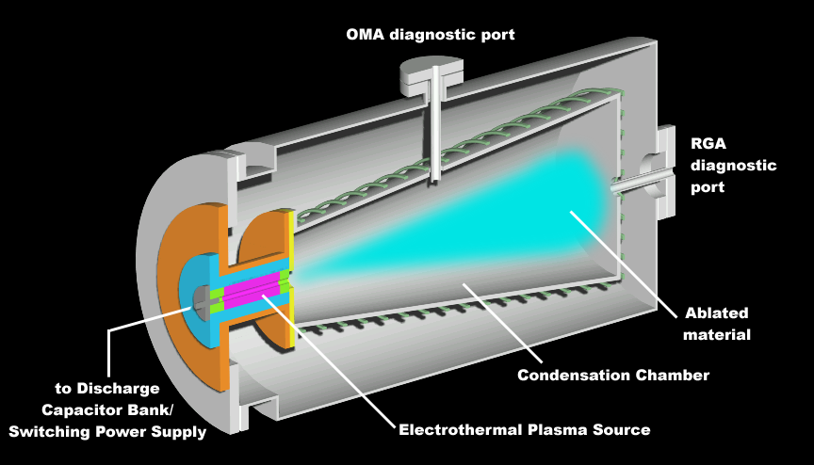

“MeSO Jet” - Turbulent Slab Jet Flow Experiments

Goal: to determine surface wave character, slab contraction length, and ultimate breakup length of stationary and oscillating liquid slab jets - optimize nozzle design for IFE applications
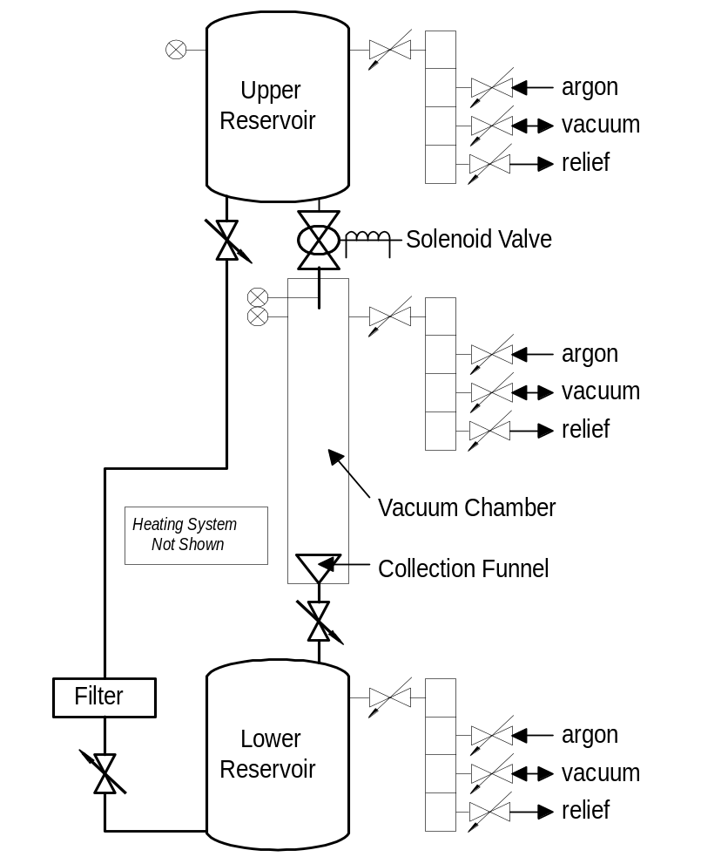
- Low volatility liquid metal is driven through interchangeable nozzle assembly into transparent vacuum chamber by variable pressurization of upper reservoir
- Jet image is recorded with high speed digital camera
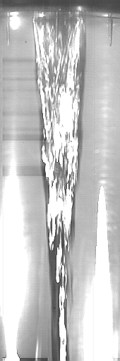
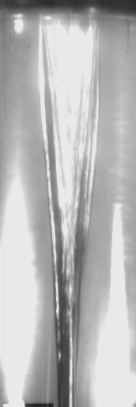
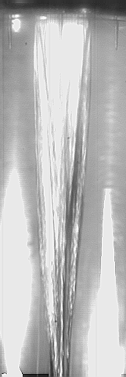
- Photographs are analyzed with motion analysis software
V=3.5 m/s
Re = 13k
We = 565

V=7.7 m/s
Re = 28k
We = 2680

V=10.3 m/s
Re = 38k
We = 4770

“POPOFF” - Liquid Fracture Experiments

Goal: to measure the fracture strength of various chamber relevant liquids (Li, Flibe Pb-Li, Pb) to fast tensile waves generated from X-ray ablation induced shocks and neutron isochoric heating
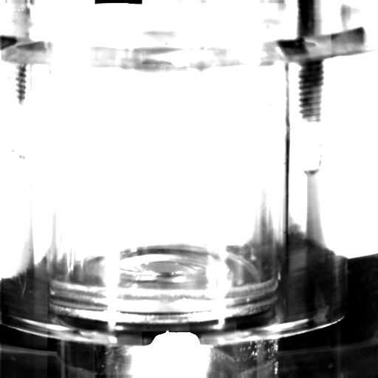
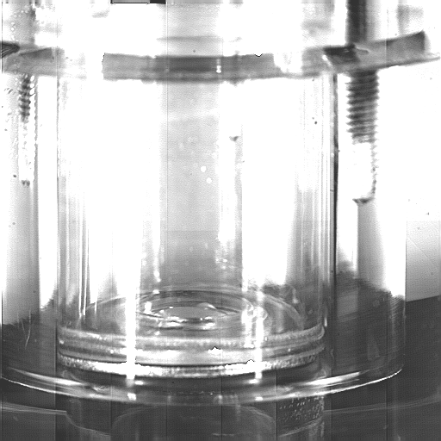
Surface distention
Hg surface
Laser blowoff
Liquid fracture experiment photographs:
(a) Laser impact at time zero and
(b) 0.5 mm bulbous distention of the free surface 3.5 ms later

